Swinburne University of Technology

*COS20019 Cloud Computing Architecture*

*­­­*­­­­

Module 11 Guided Lab - Streaming Dynamic Content using Amazon CloudFront

*Sunday 25th September, 2023*

Name: Phan Vu - ID: 104222099

**TASK 1: Lab Preparation**

5. In the AWS Management Console, on the Services menu, choose S3.

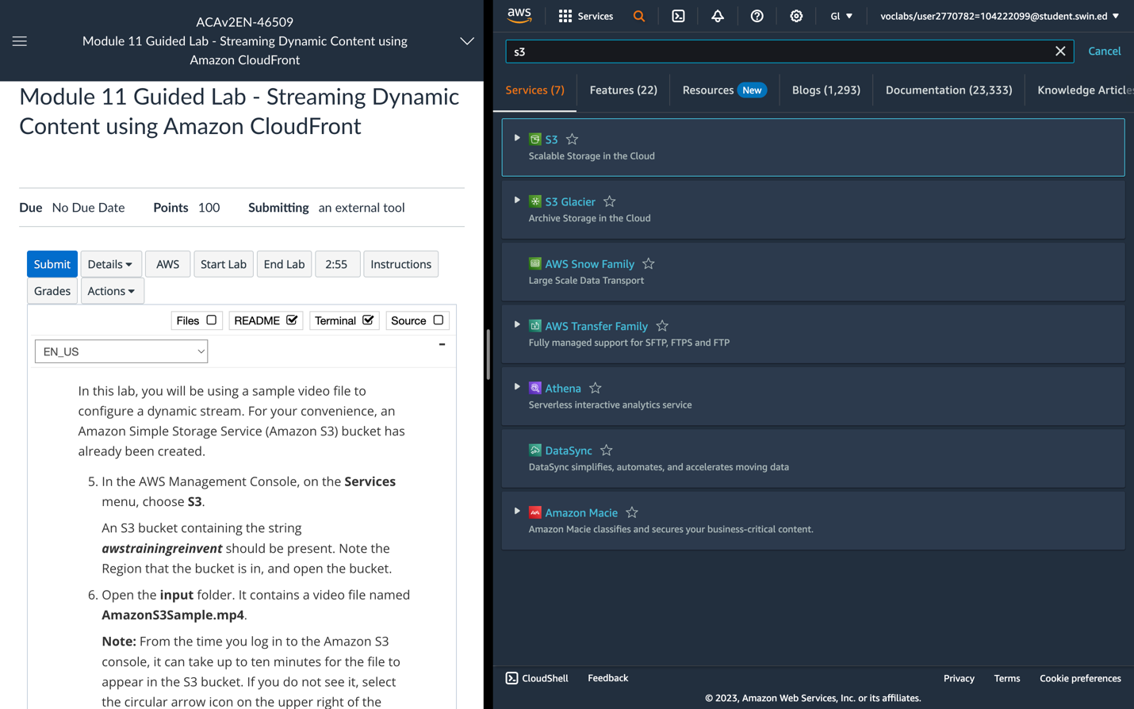

An S3 bucket containing the string ***awstrainingreinvent*** should be present. Note the Region that the bucket is in, and open the bucket.

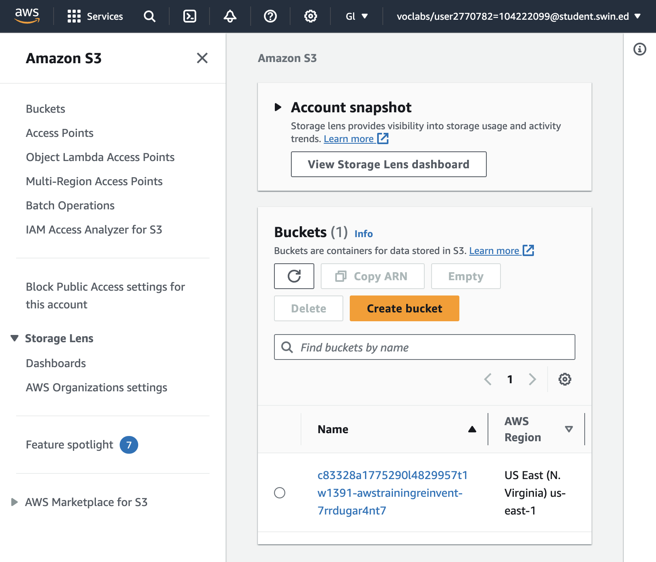

6. Open the **input** folder. It contains a video file named **AmazonS3Sample.mp4**.

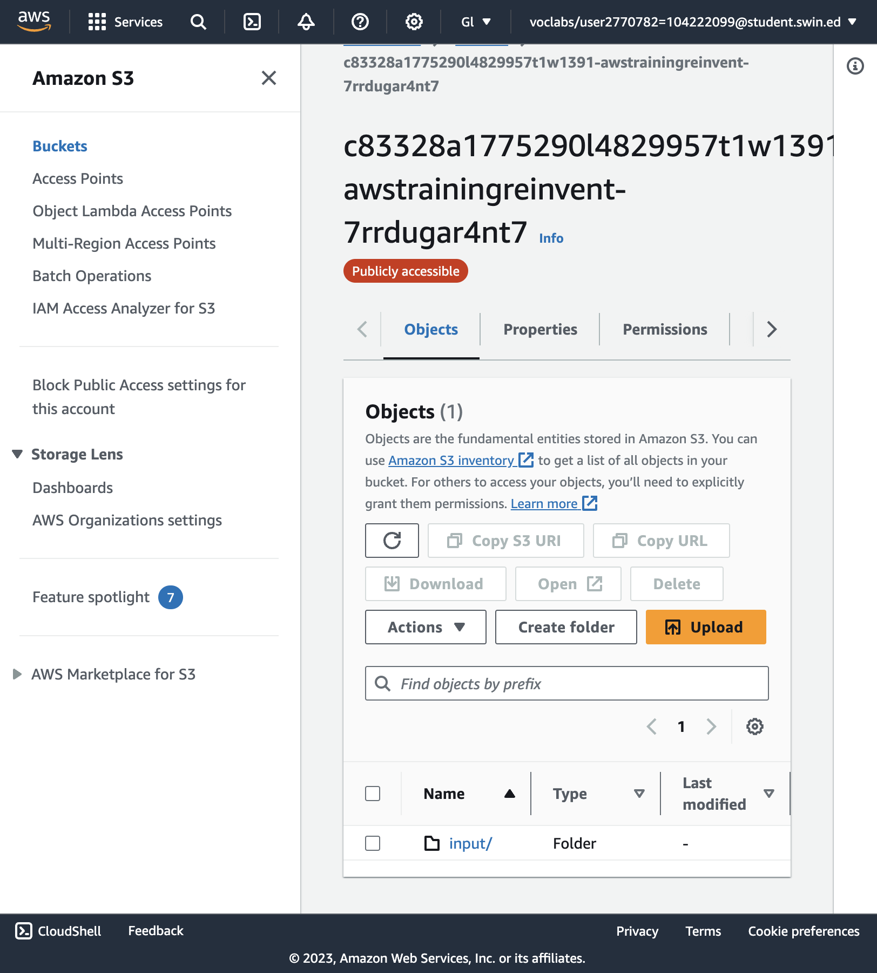

**“Input”** folder

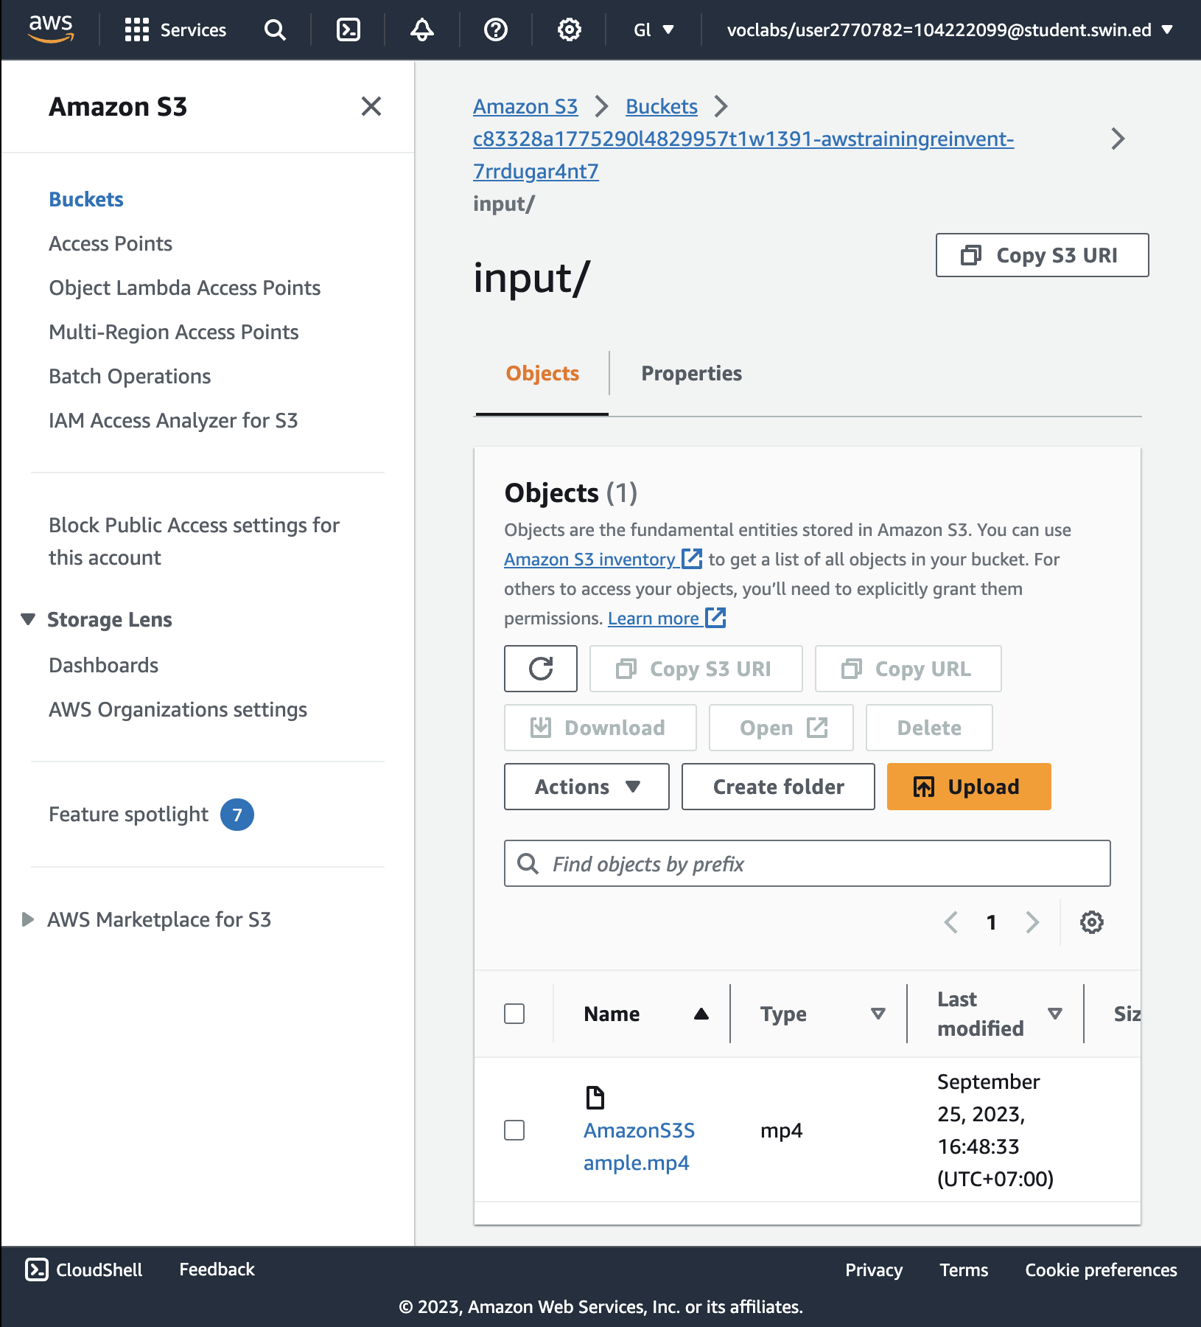

**AmazonS3Sample.mp4**

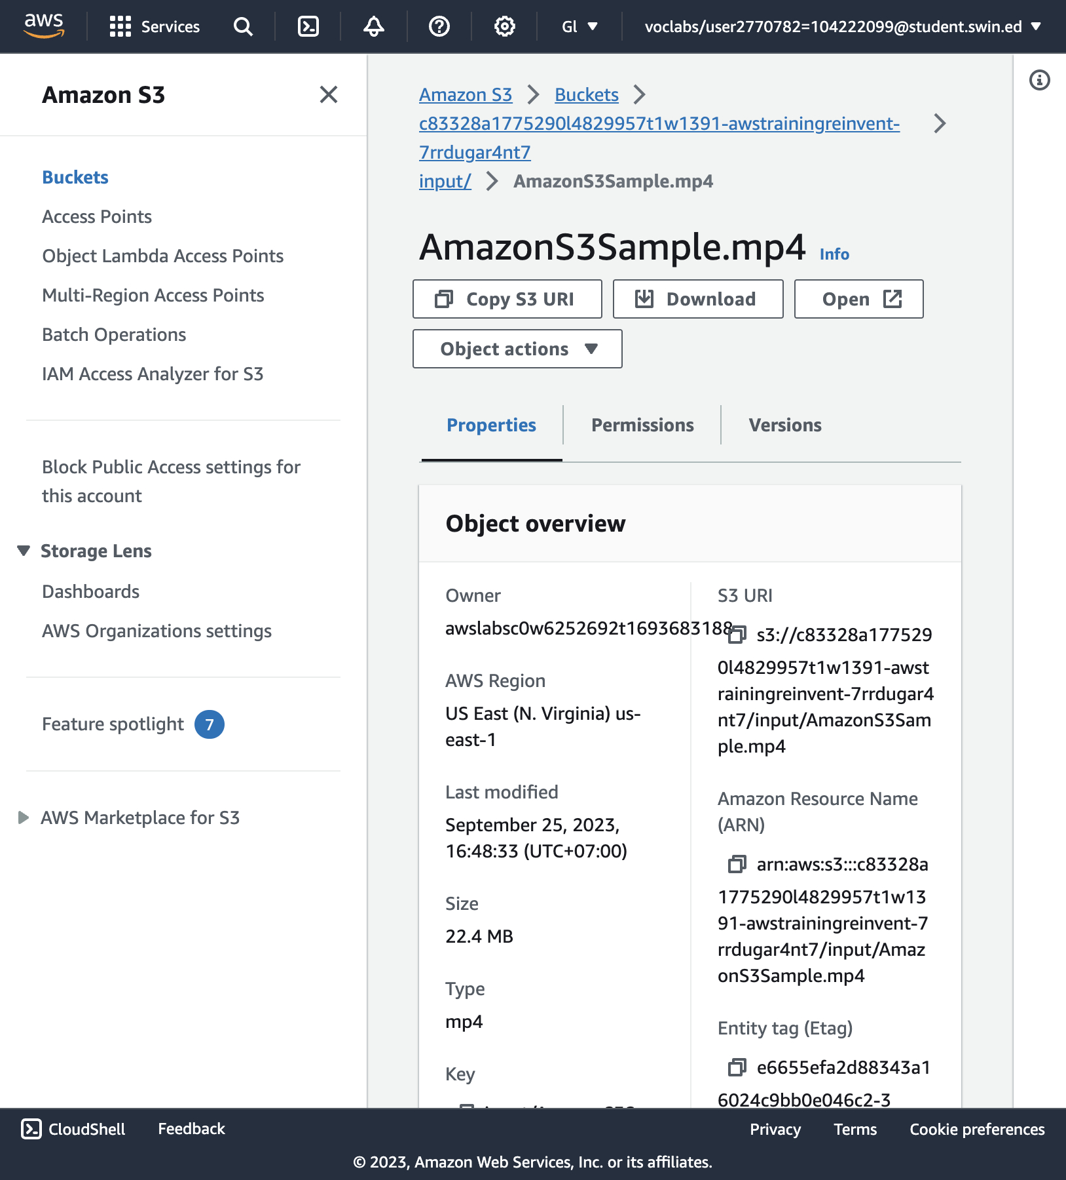

Inside of the **AmazonS3Sample.mp4** after opened

**TASK 2: Create an Amazon CloudFront Distribution**

7. On the **Services** menu, choose **CloudFront**.

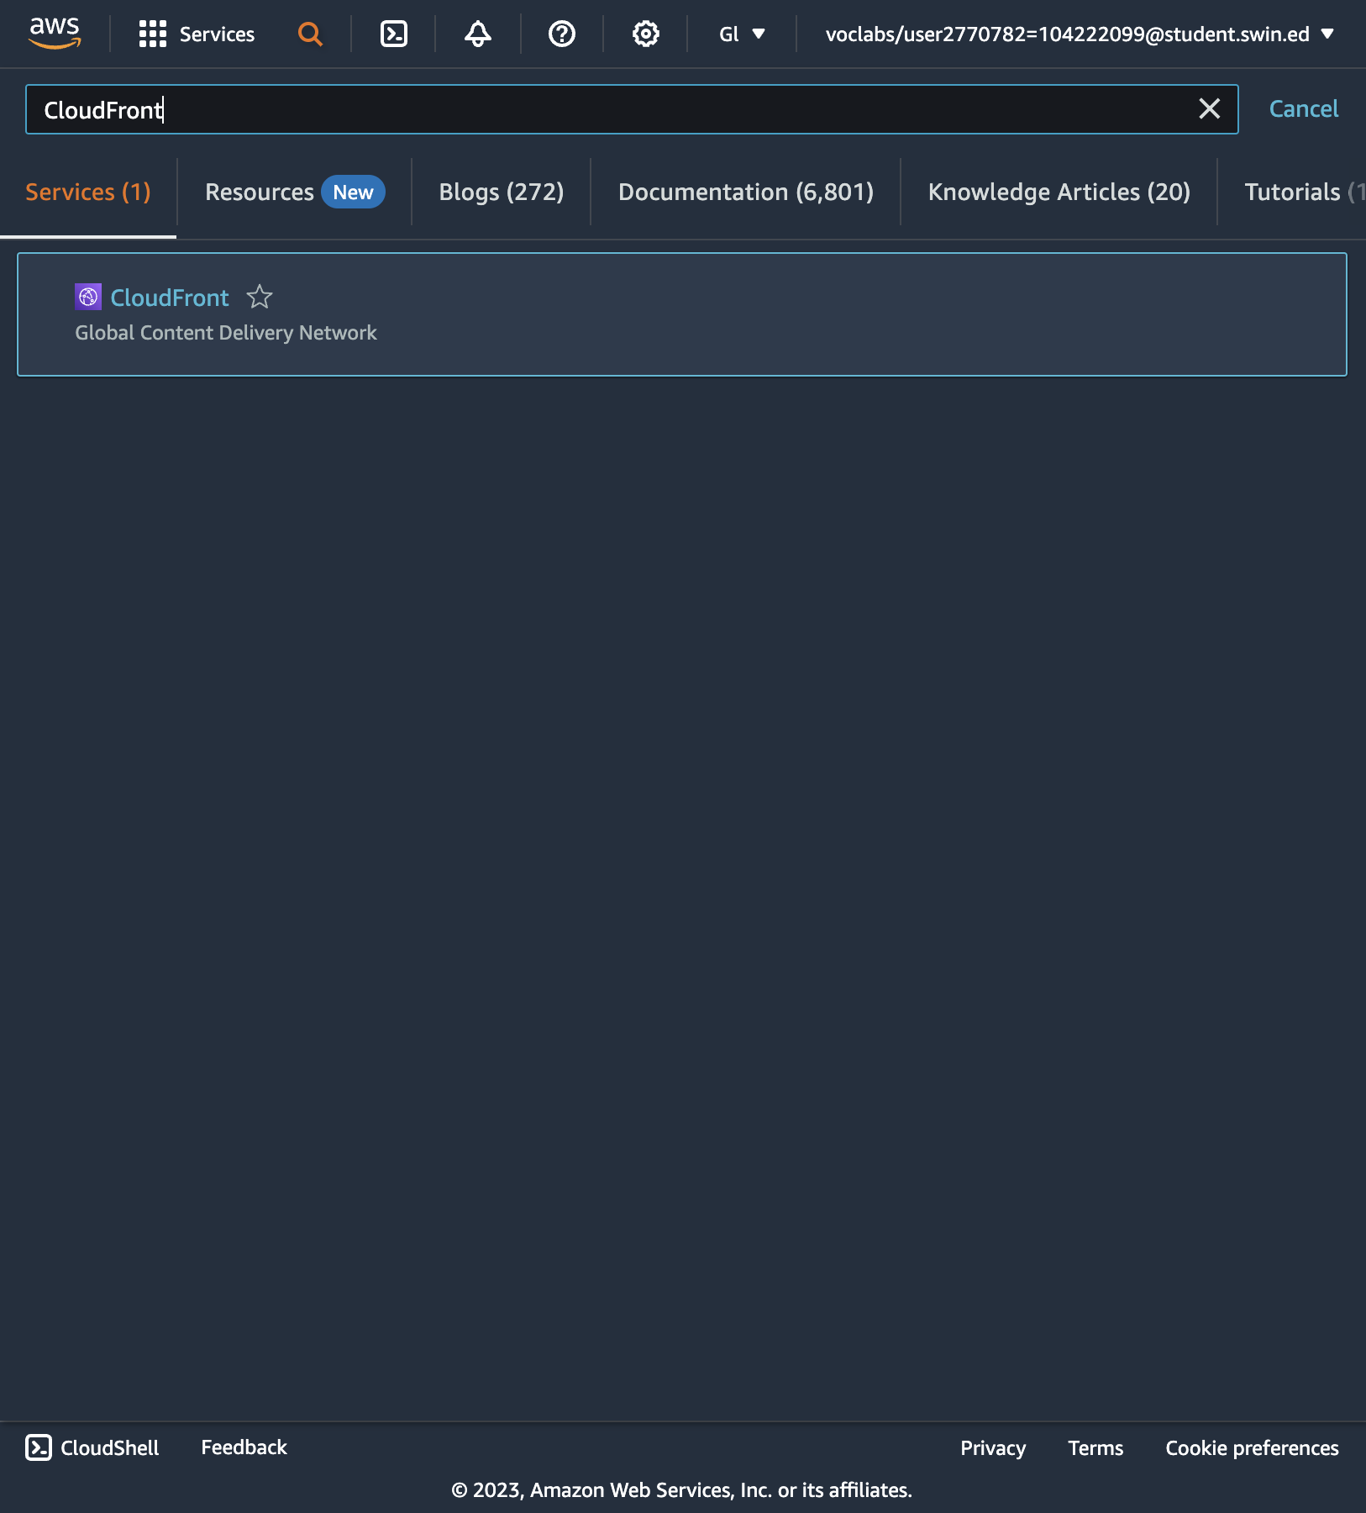

8. Choose **Create a CloudFront distribution**.

And configure the setting:

* Select the **Origin domain** field. A list of S3 buckets will appear. Choose the one that was created earlier that has **awstrainingreinvent** as part of the file name.
* Leave **Origin access** as **Public**.
* Under **Web Application Firewall (WAF)** select **Do not enable security protections**.

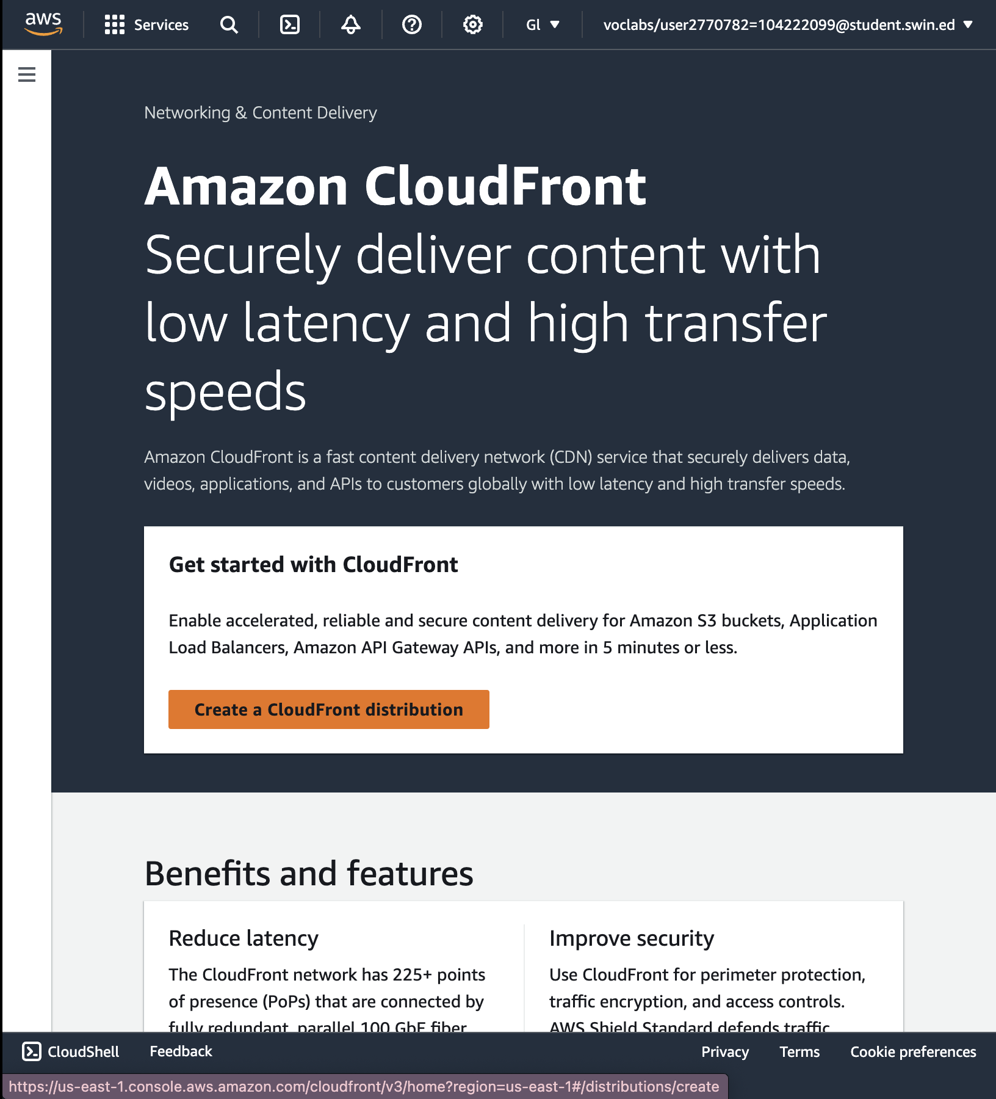

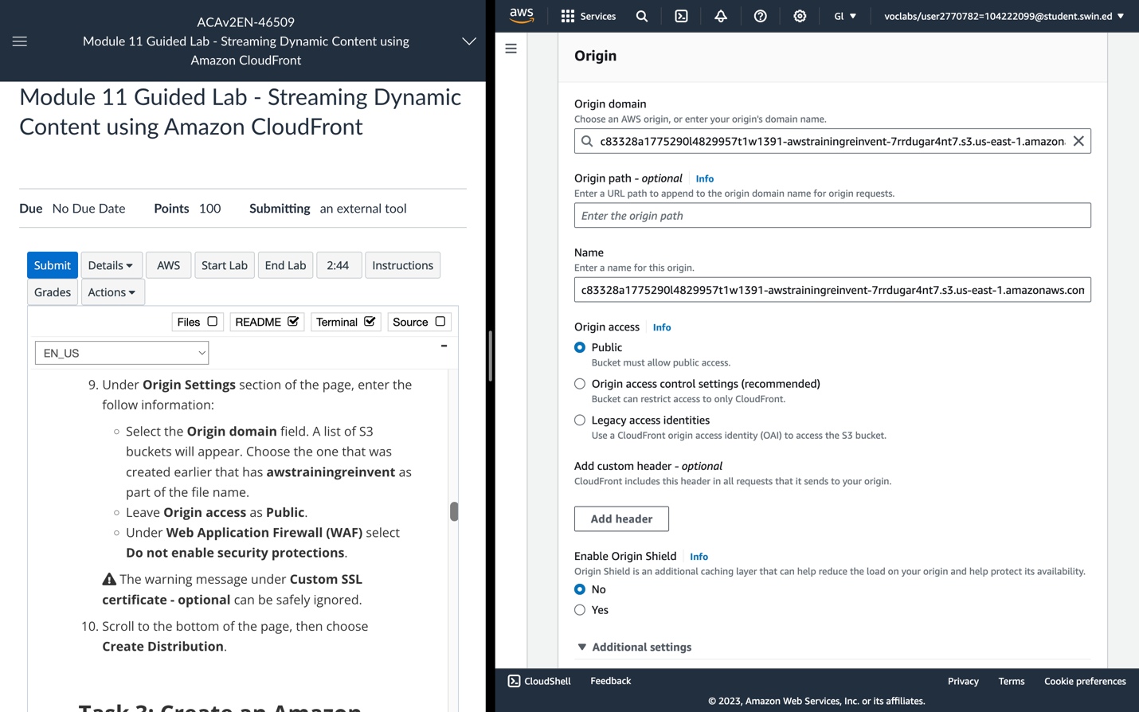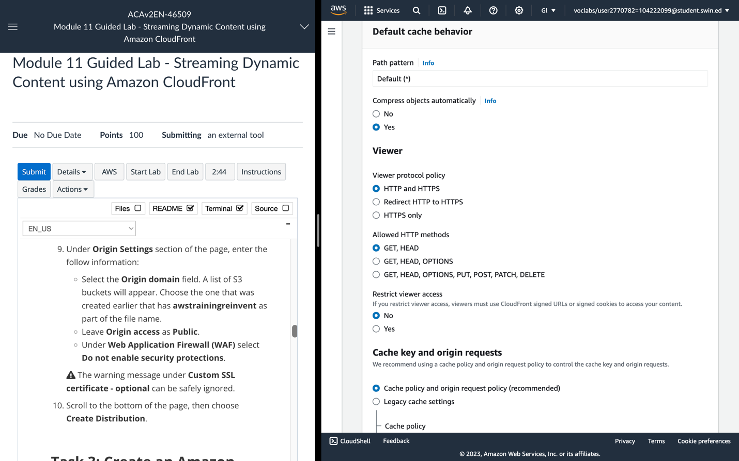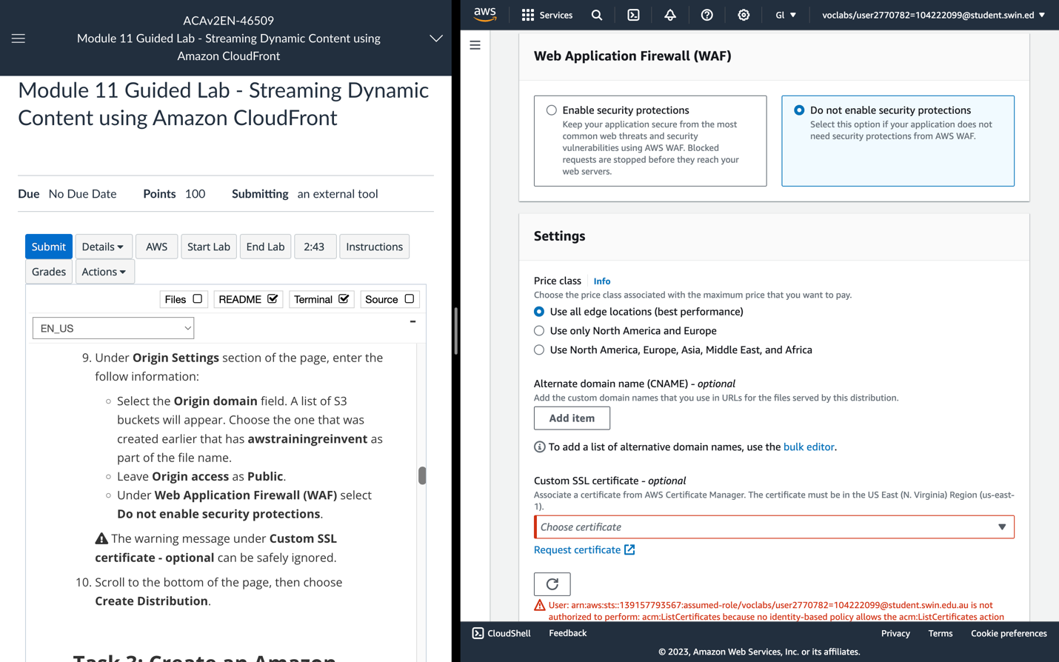

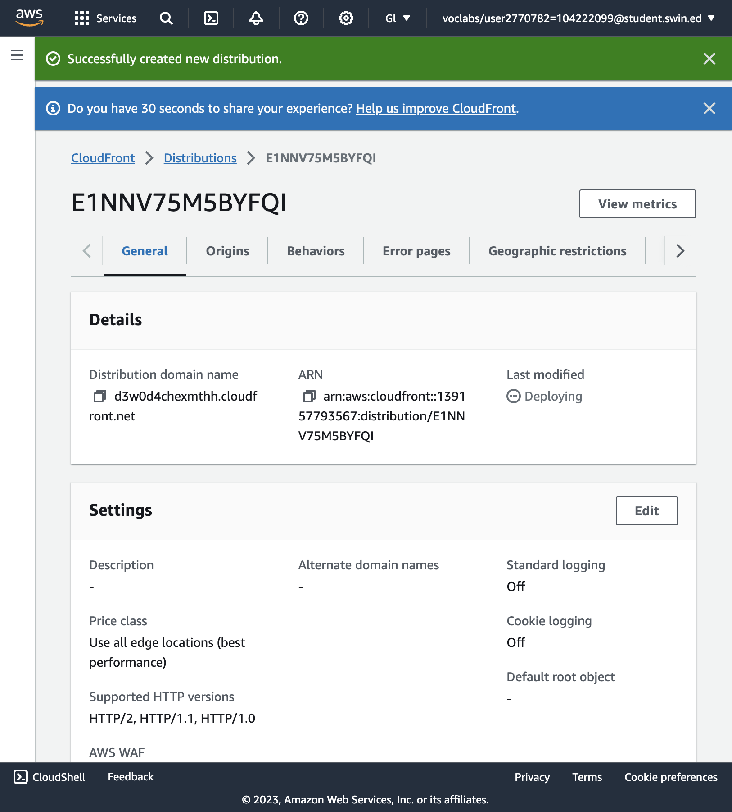

Successfully created new distribution

**TASK 3: Create an Amazon Elastic Transcoder Pipeline**

**Create a Pipeline**

11. In the AWS Management Console, on the **Services** menu, choose **Elastic Transcoder**.

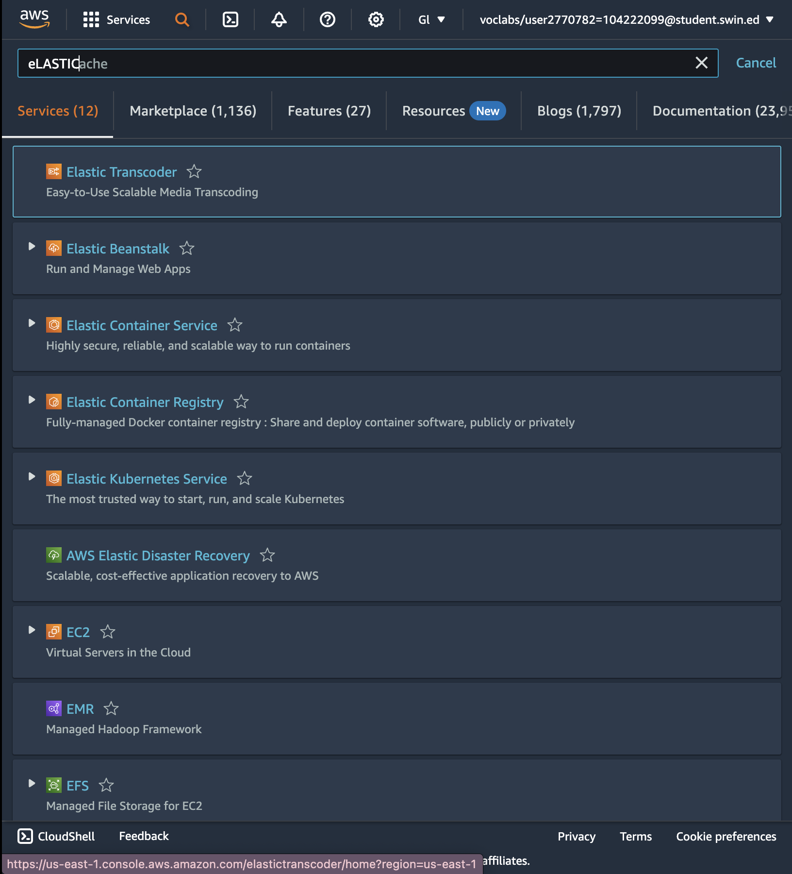

12. In the navigation bar of the Amazon Elastic Transcoder console, select the same Region that the S3 bucket was created in.

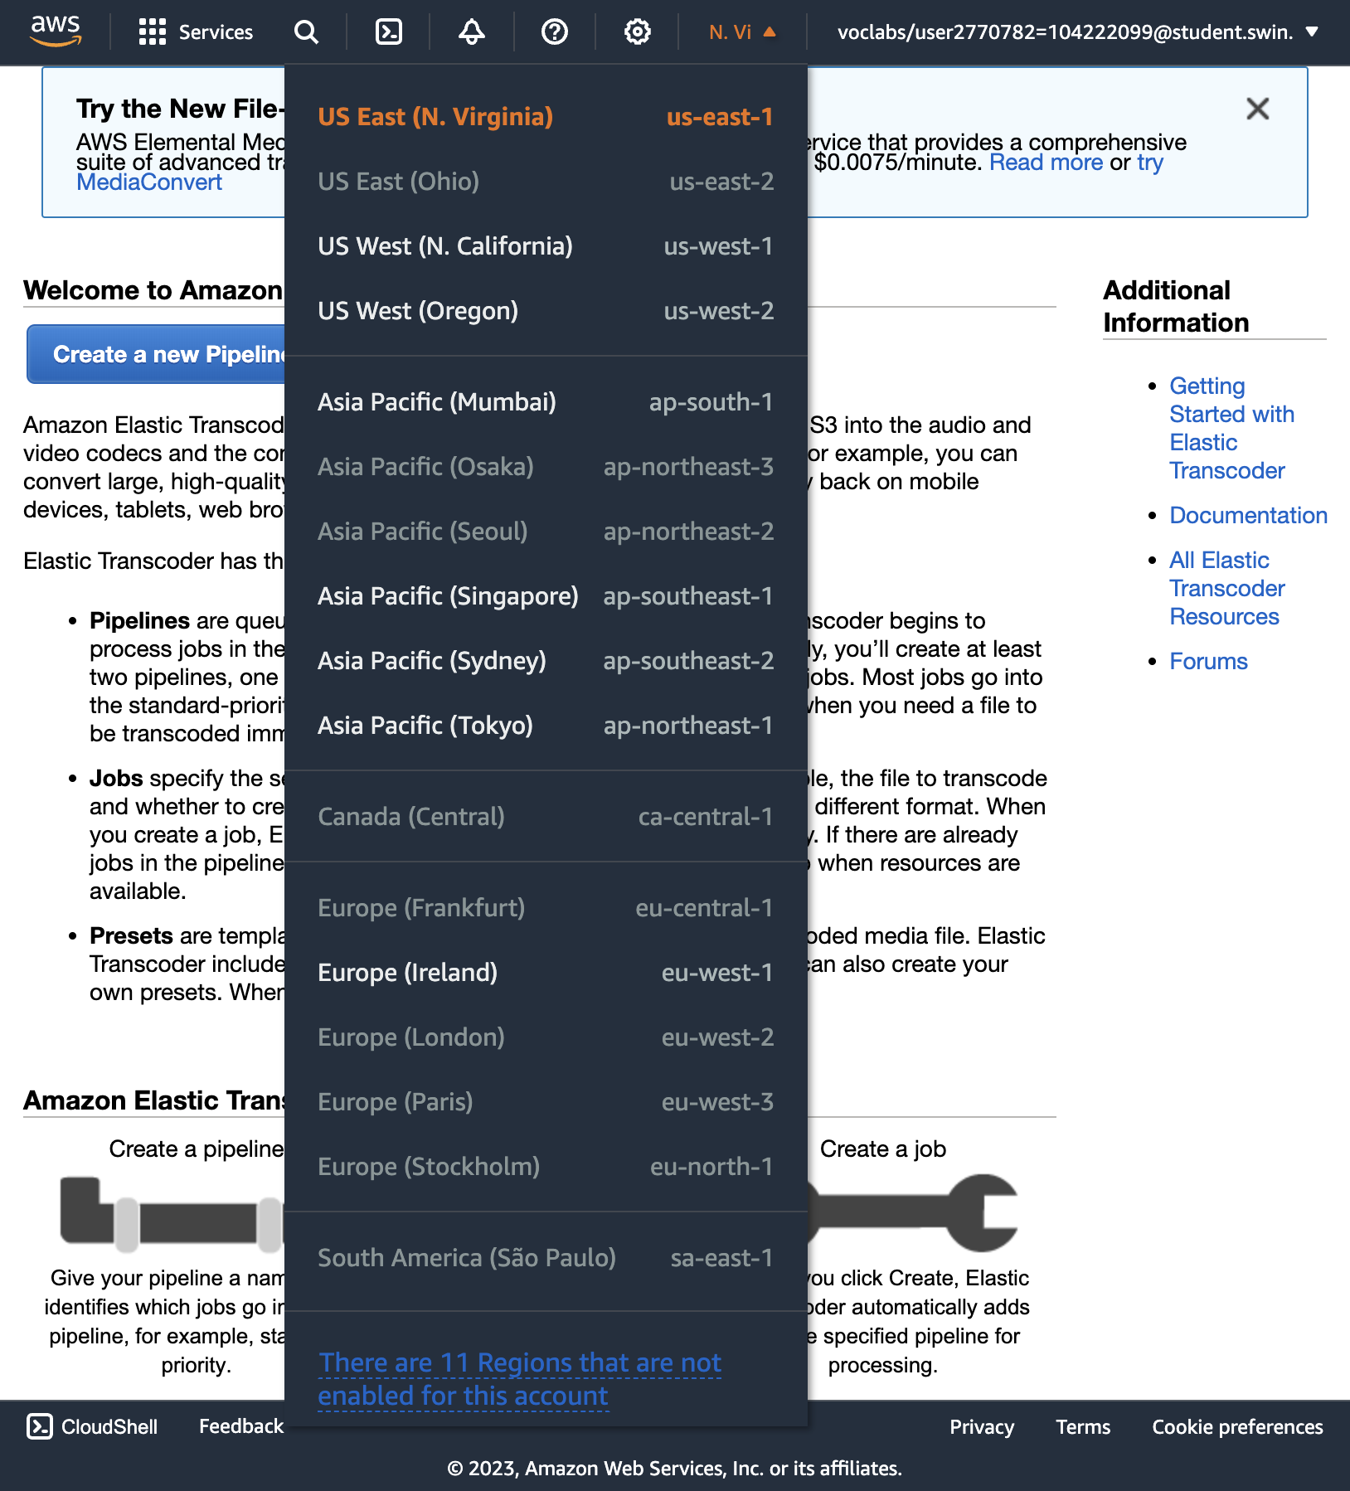

13. On the Pipelines page, choose **Create a new Pipeline**.

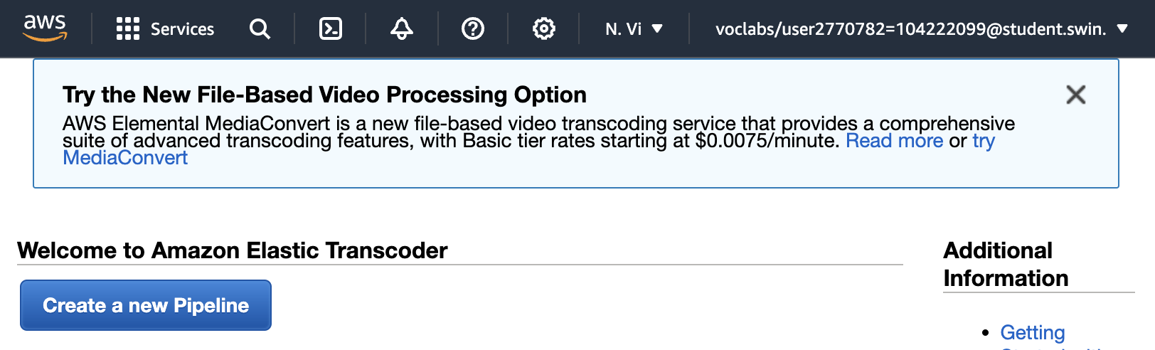

* For **Pipeline Name**, enter InputPipeline
* For **Input Bucket**, select the **awstrainingreinvent** S3 bucket.
* For **IAM Role**, under **Other roles**, select **AmazonElasticTranscoderRole**. This role was pre-created in this lab's CloudFormation template that uses the managed policy AmazonElasticTranscoderRole. The Elastic Transcoder service will assume this role to access Amazon S3 and Amazon Simple Notification Service (Amazon SNS) resources in your lab account.

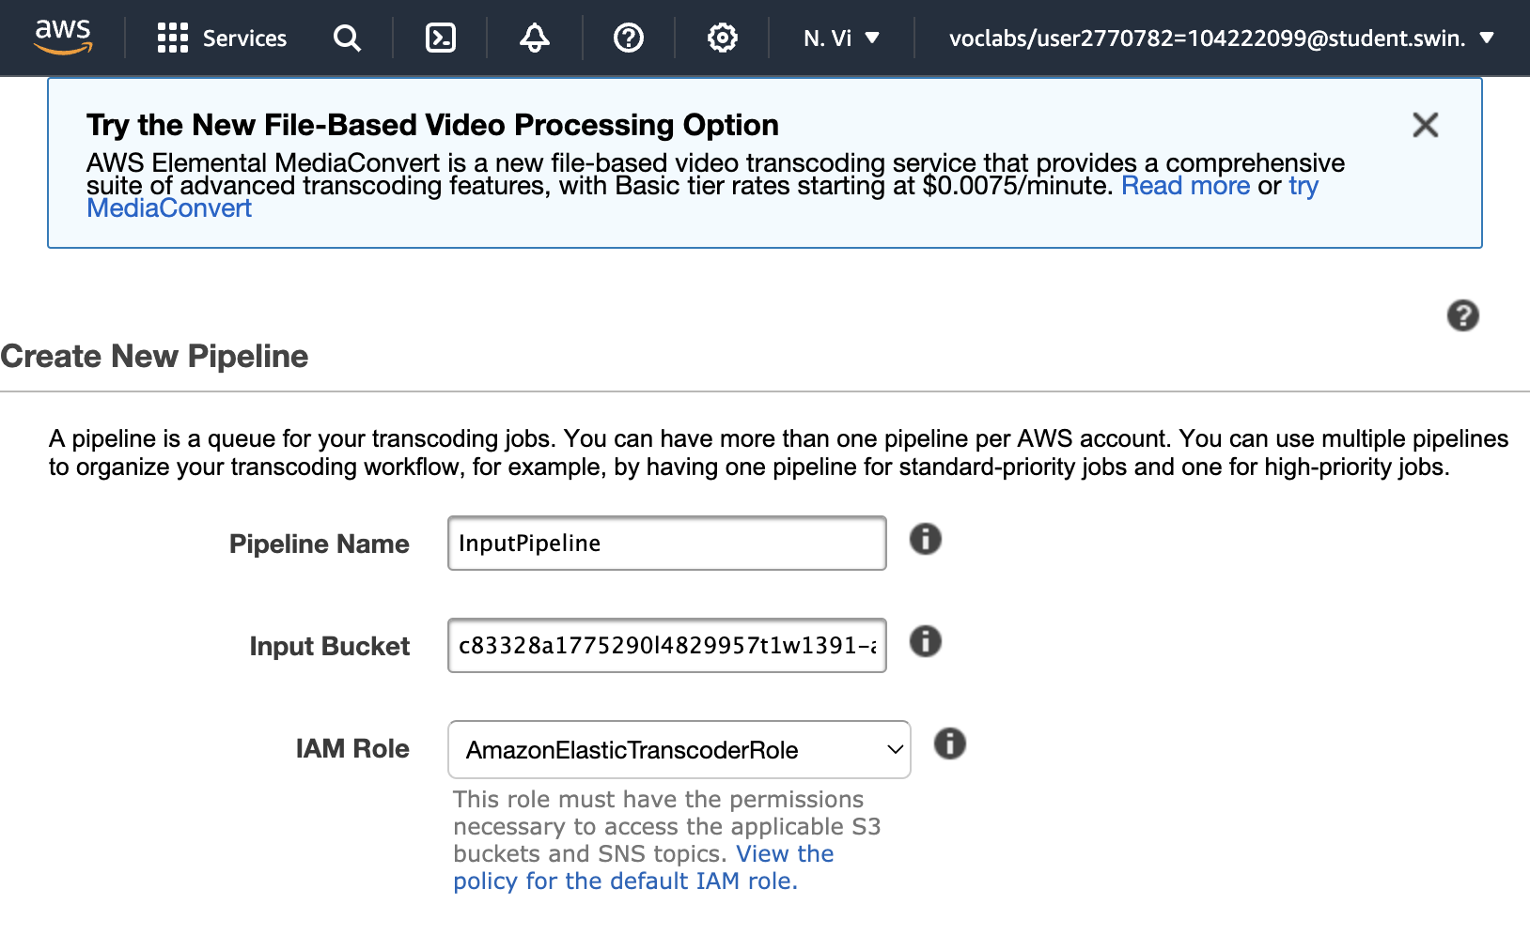

17. In the **Configuration for Amazon S3 Bucket for Transcoded Files and Playlists** section, enter the follow information:

* Under **Bucket**, select the **awstrainingreinvent** S3 bucket.
* Under **Storage Class**, select **Standard**.

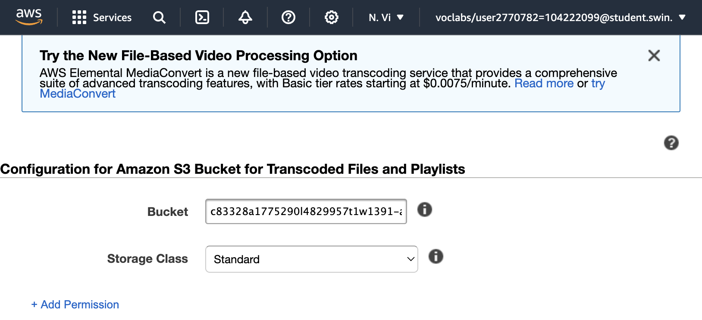

18. In the **Configuration for Amazon S3 Bucket for Thumbnails** section, enter the following information:

* Under **Bucket**, select the **awstrainingreinvent** S3 bucket.
* Under **Storage Class**, select **ReducedRedundancy**.

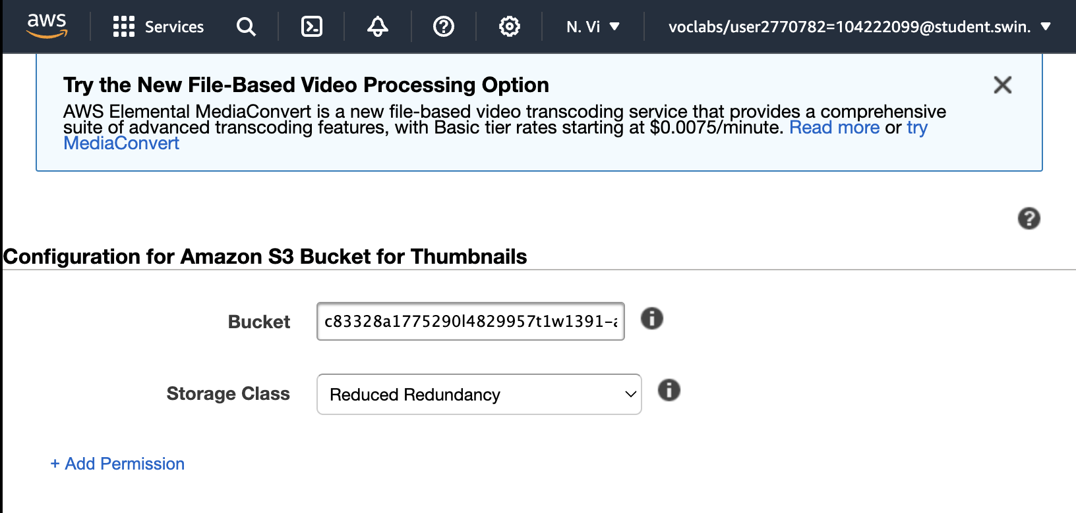

19. Choose **Create Pipeline**.

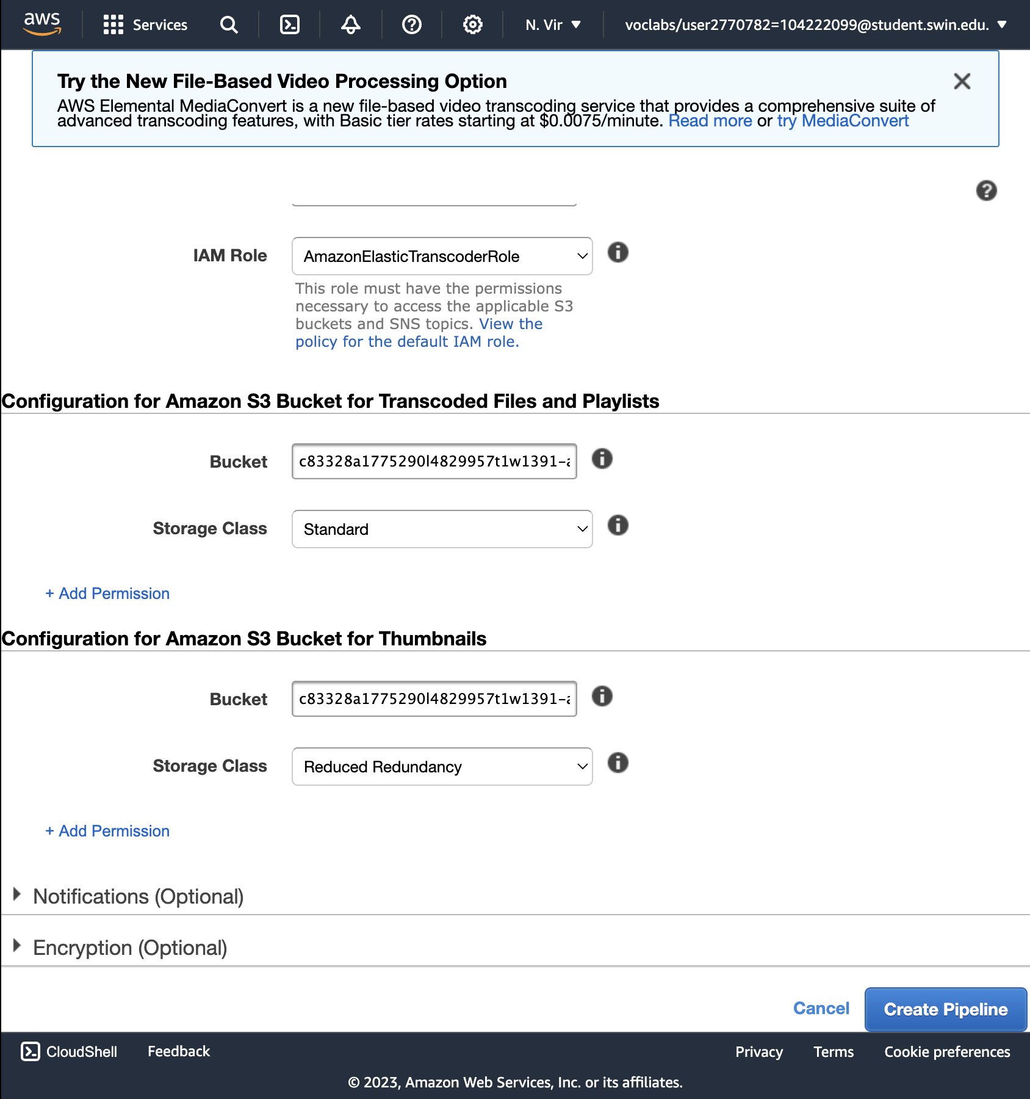

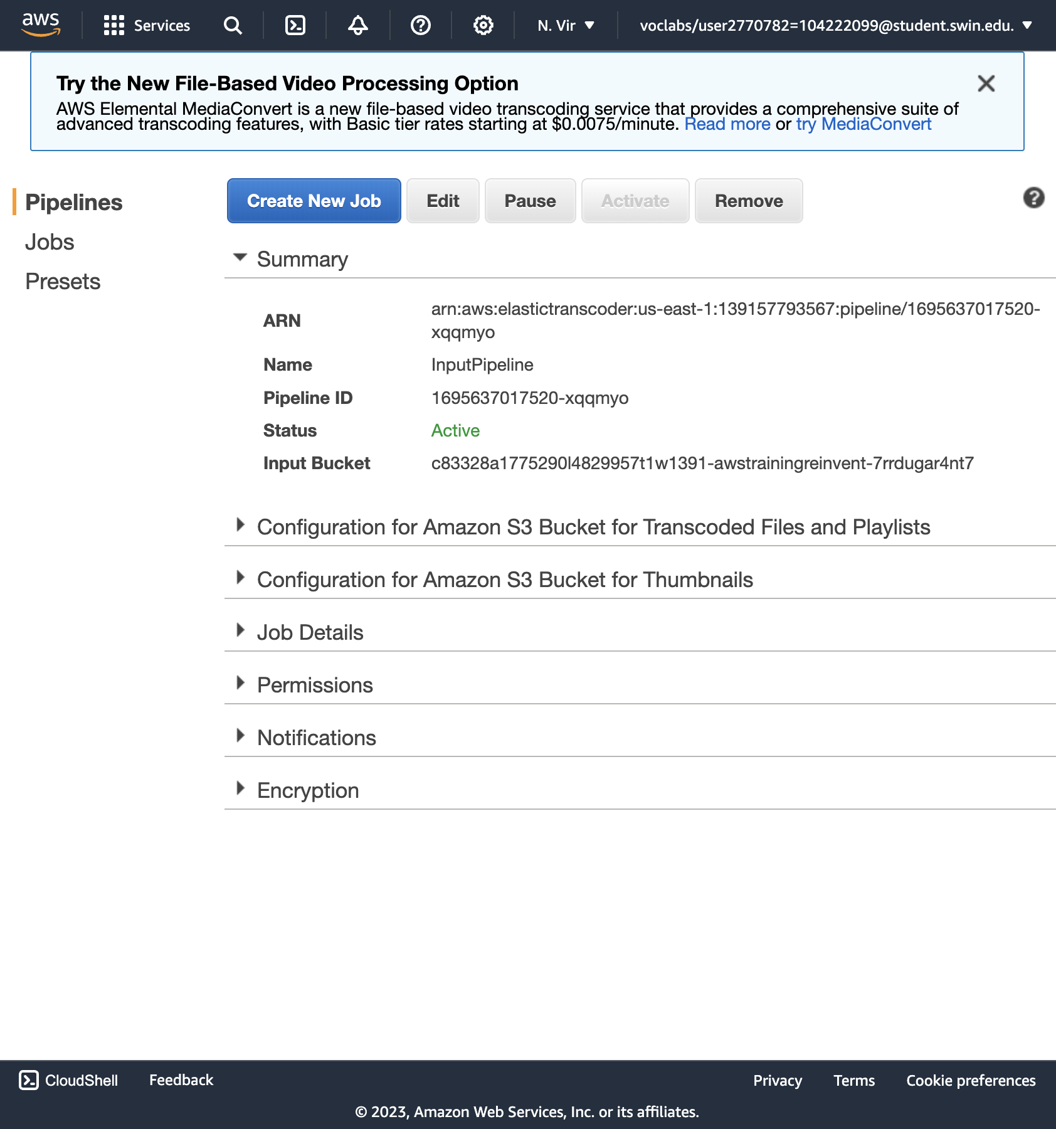

**Create a Job**

20. On the Pipelines page, choose **Create New Job** to create a transcoding job. You create the job in the pipeline (queue) that you want to use to transcode the video file.

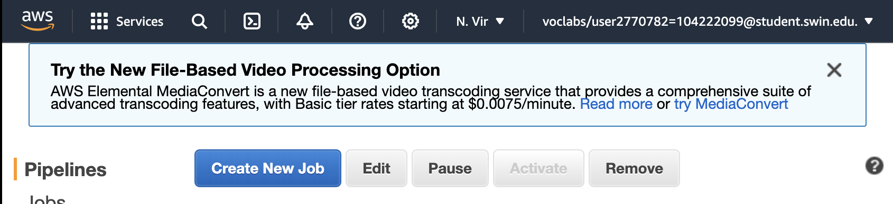

* For **Pipeline**, select **InputPipeline**.
* For **Output Key Prefix**, enter output/.

Amazon Elastic Transcoder will prepend this value to the names of all files that the job will create (including output files, thumbnails, and playlists).

* For **Input Key**, select the input file labeled **input/AmazonS3Sample.mp4.**

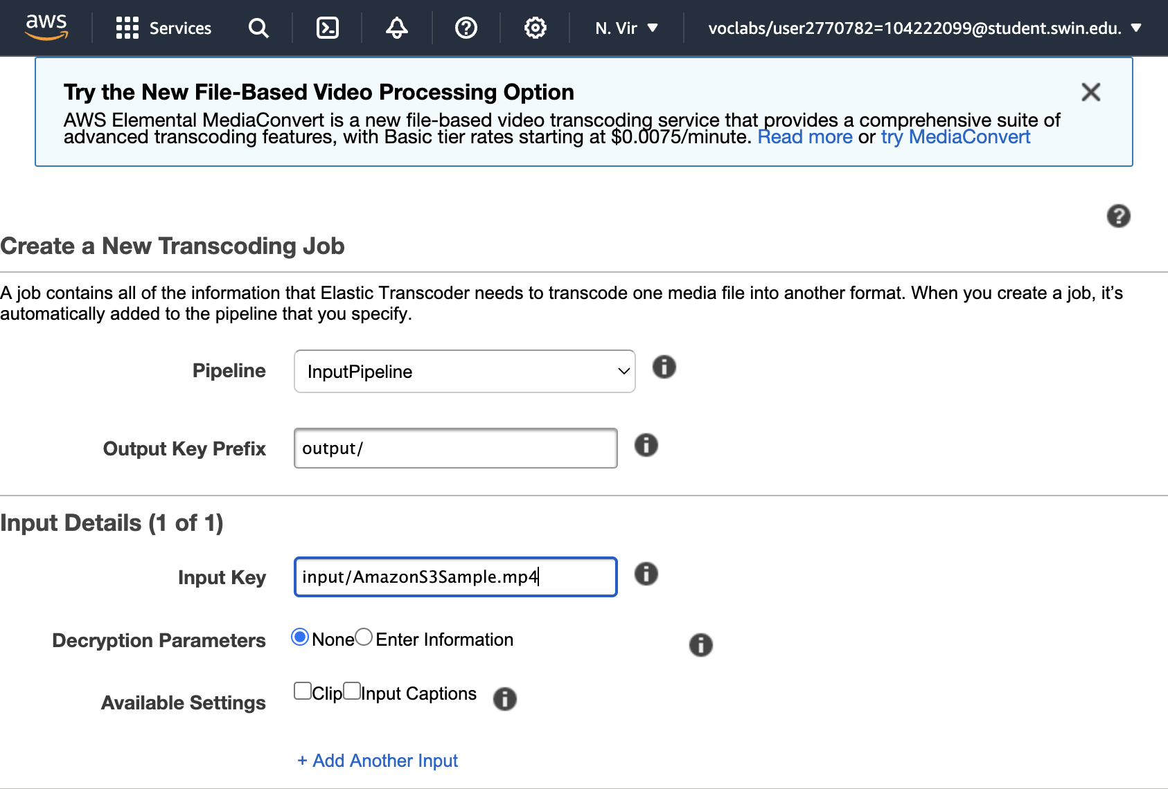

**Configure Output Details**

1. For **Preset:**, select **System preset: HLS 2M**
2. For **Segment Duration**, enter 10 (which is the HLS default).
3. For **Output Key**, enter the unique prefix HLS20M to name the segments created using this preset.
4. Click **+ Add Another Output** and repeat the steps above to generate segments for presets **HLS 1.5M** and **HLS 1M** and then provide the respective prefix names:
   * HLS15M
   * HLS10M

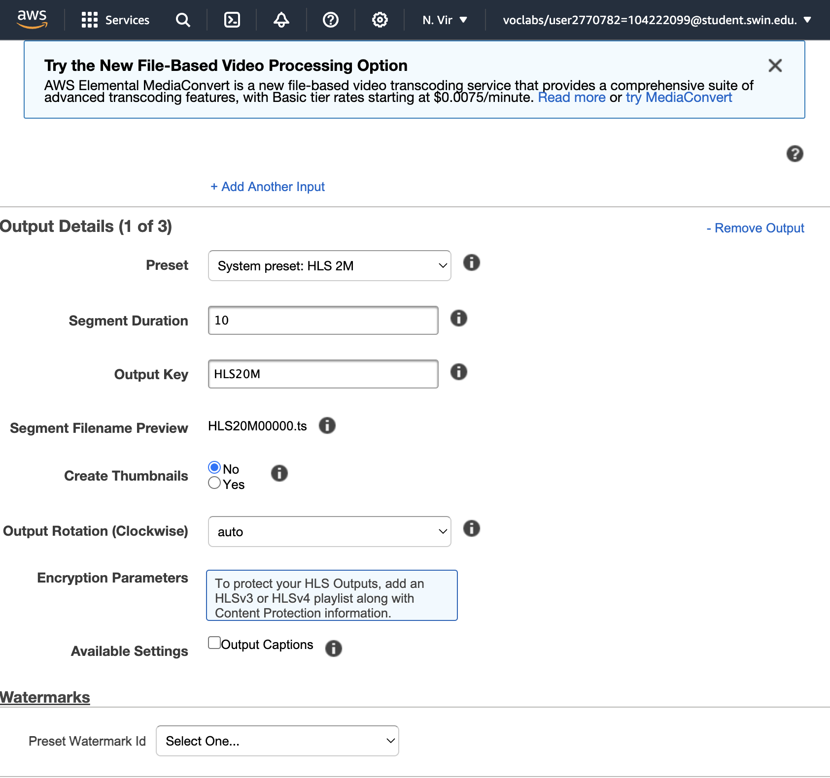

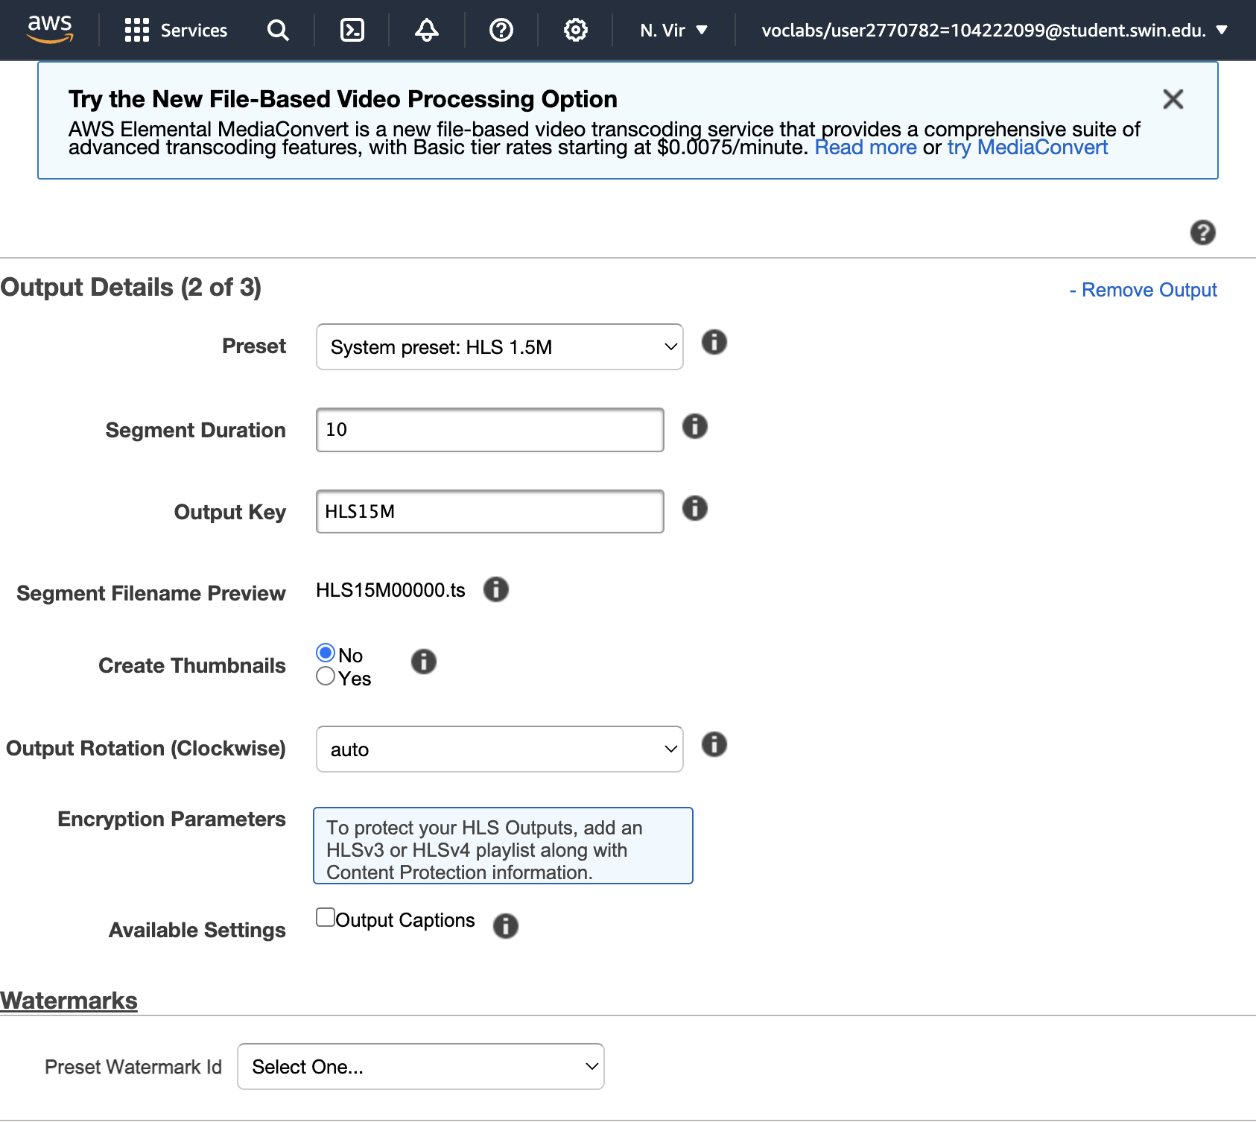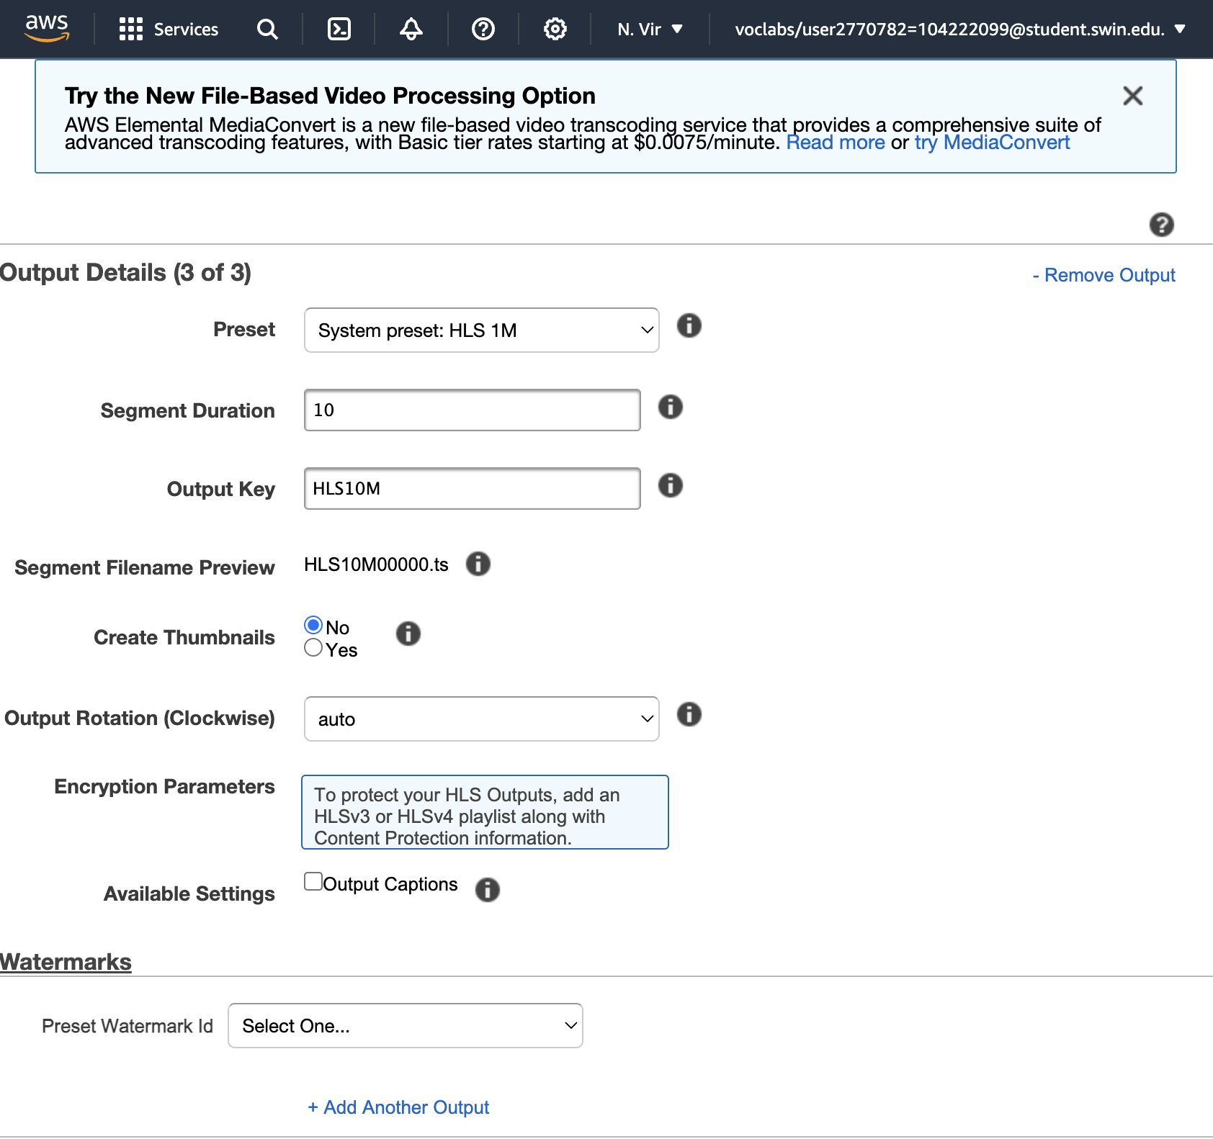

**Configure a Playlist**

1. Under **Playlists (Adaptive Streaming)**, choose **Add Playlist**, then configure:
   * **Master Playlist Name** primary
   * **Playlist Format:** *HLSv3*
2. Select all the three outputs, which were entered in the previous section, to include them in this playlist by selecting the **+** option.

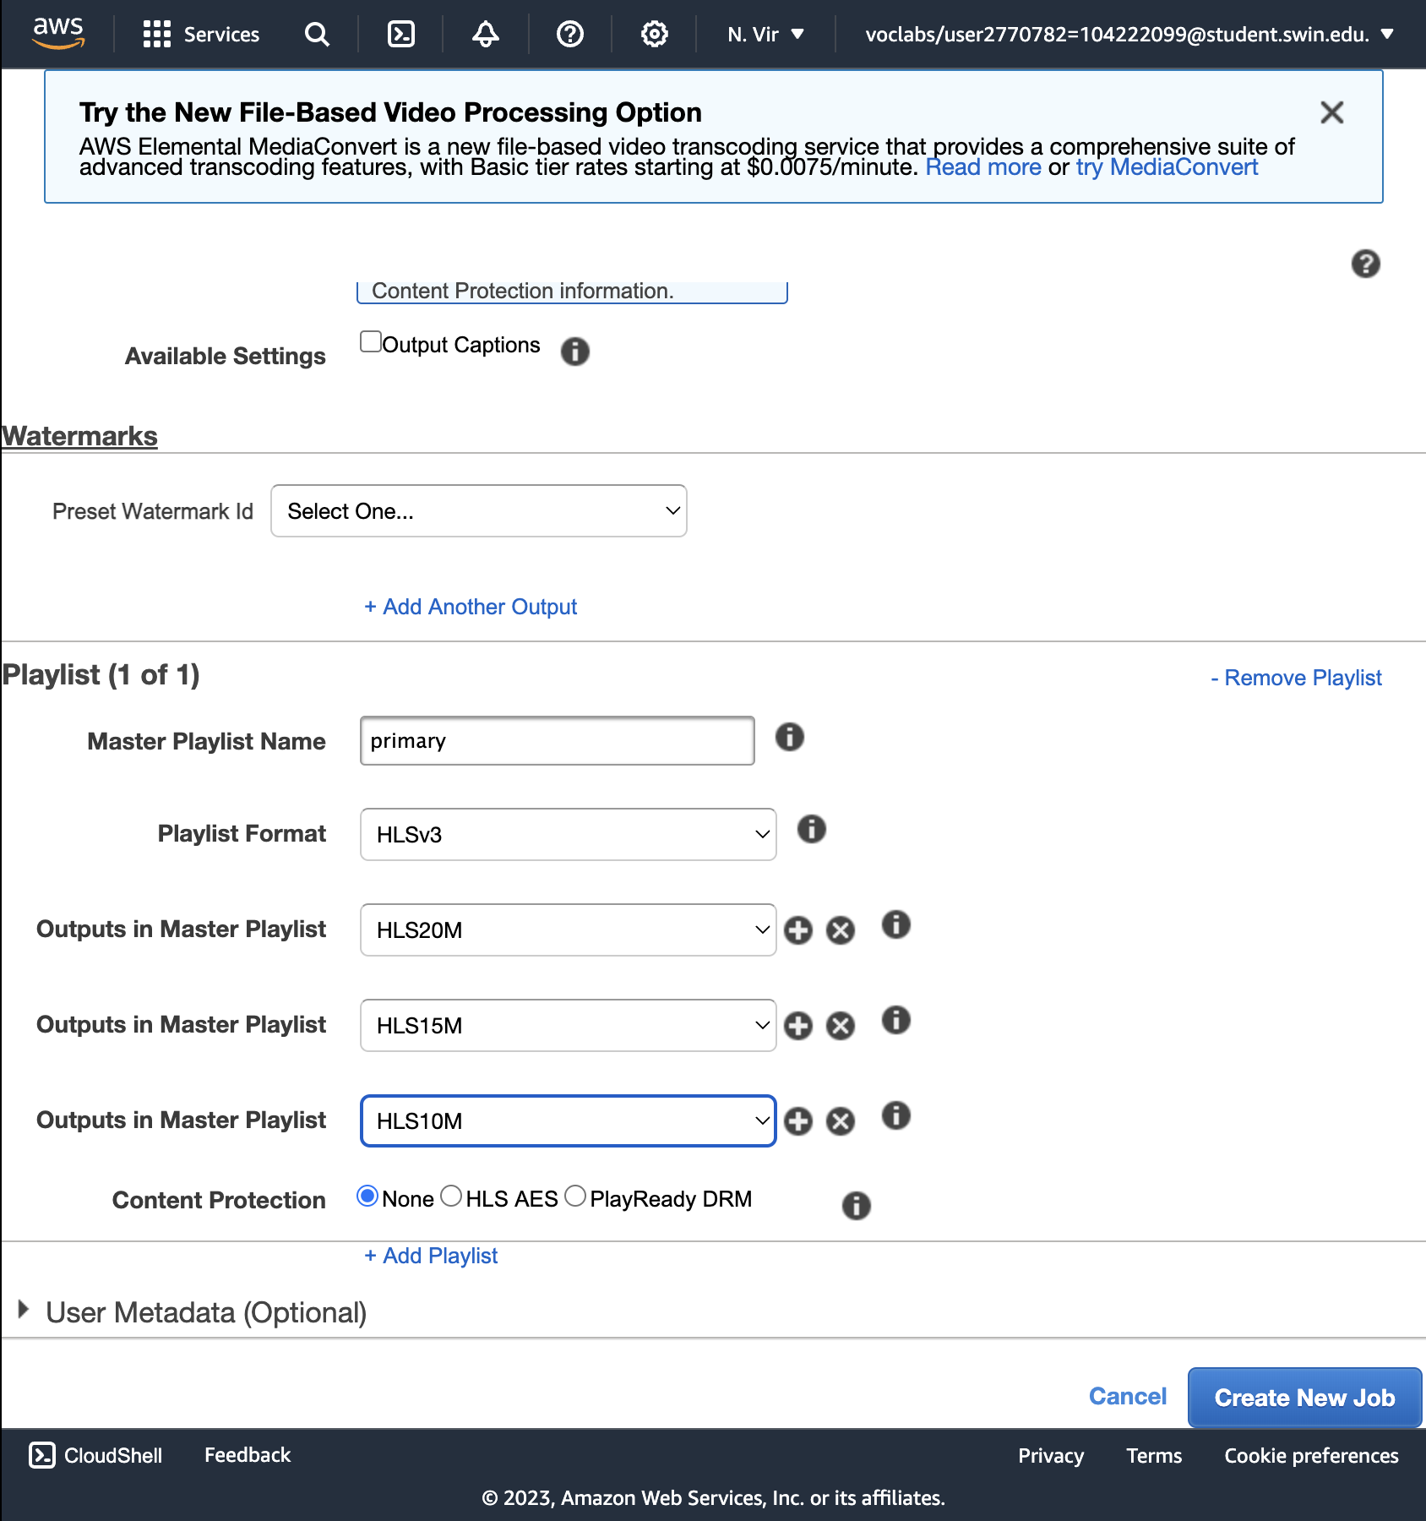

1. Choose **Create New Job**.

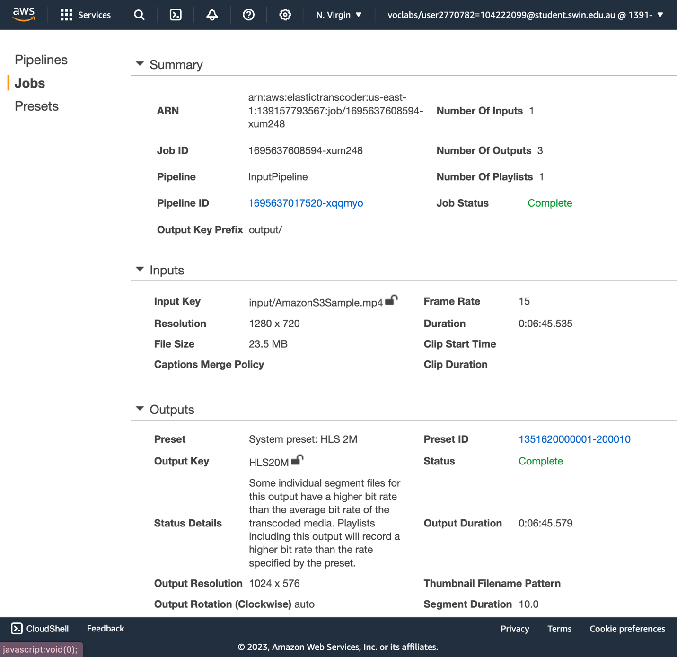

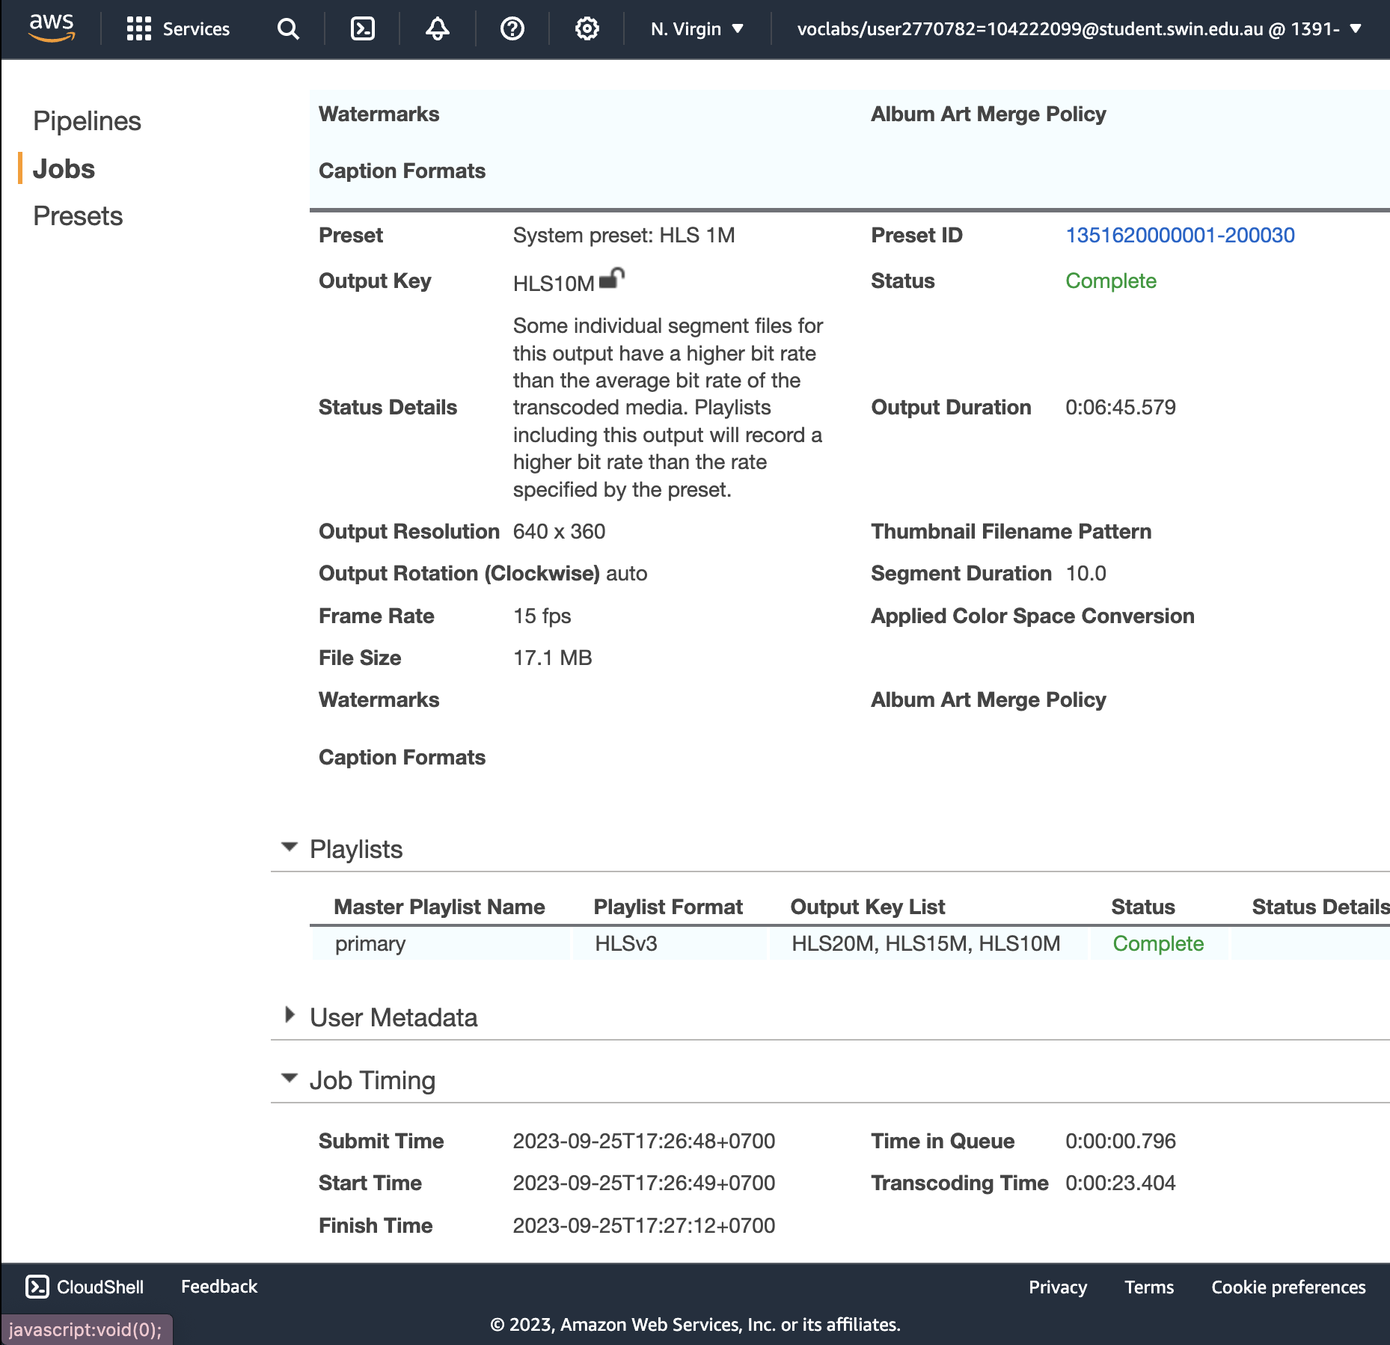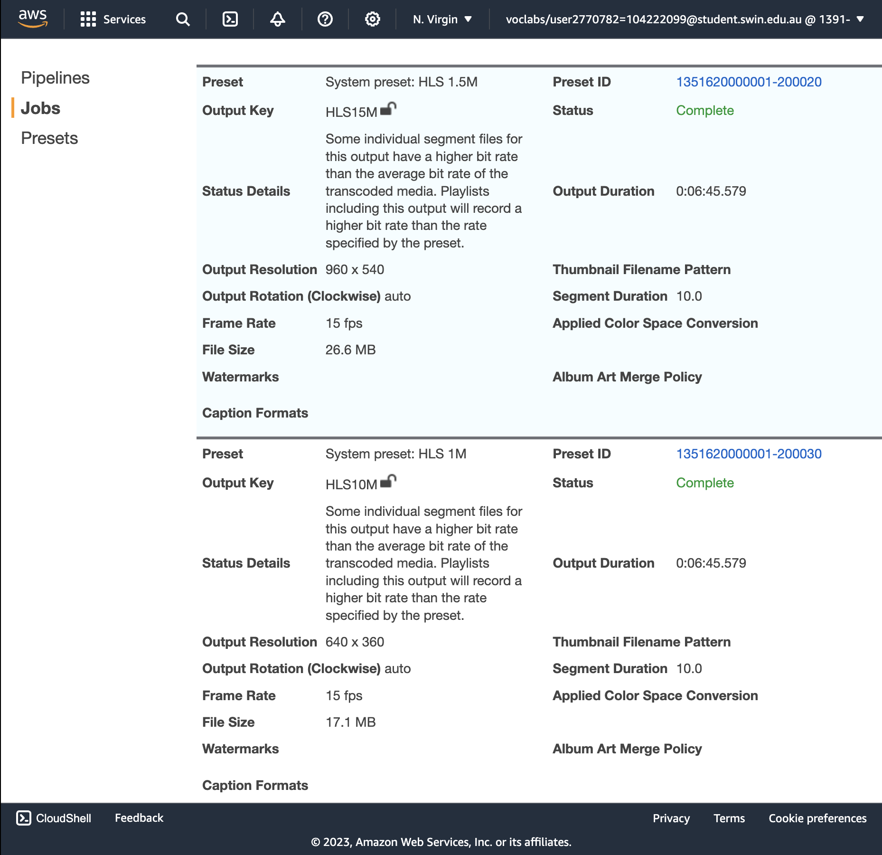

**TASK 4: Test Playback of the Dynamic (Multi Bit-Rate) Stream**

**Obtain an Amazon CloudFront Domain Name**

1. In the AWS Management Console, on the **Services** menu, choose **CloudFront**.

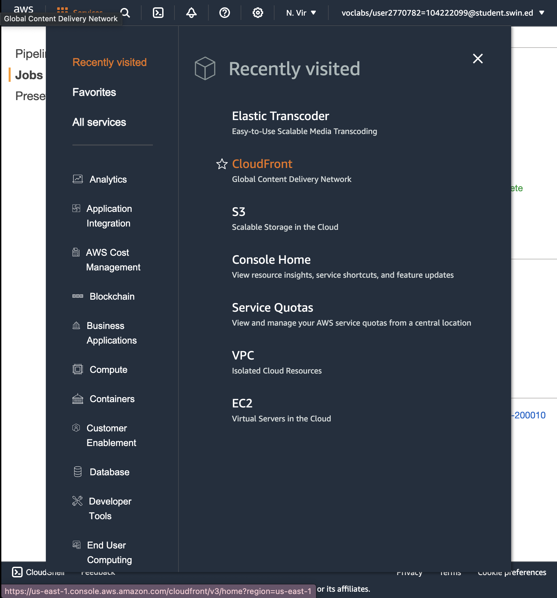

1. Select the **Amazon CloudFront** distribution that was previously created, and verify that the **Status** has changed from *InProgress* to *Enabled*.

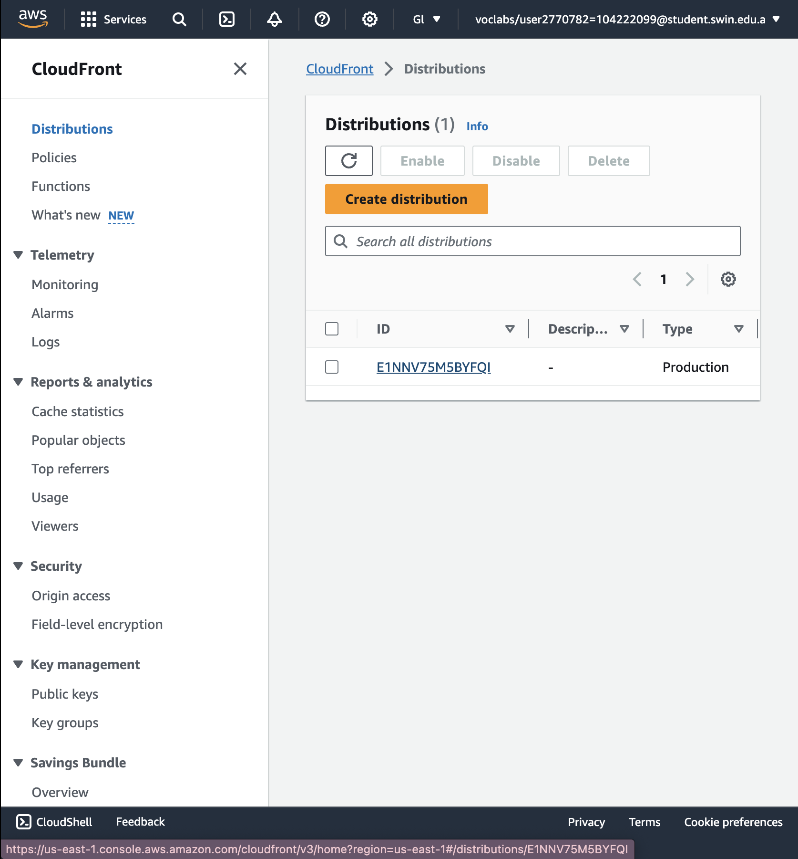

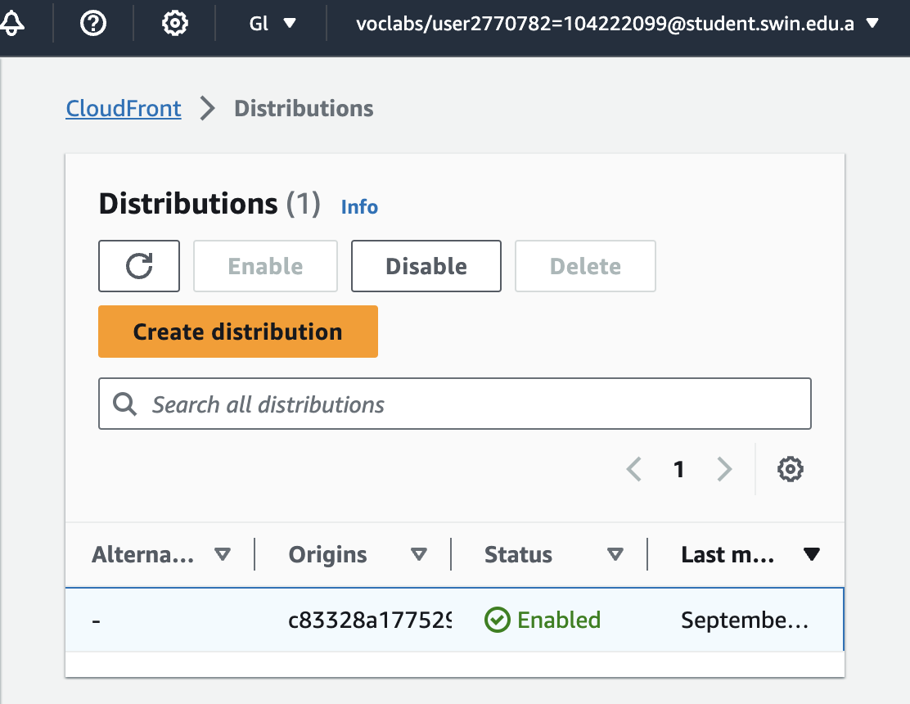

**Status** has changed from *InProgress* to *Enabled*.

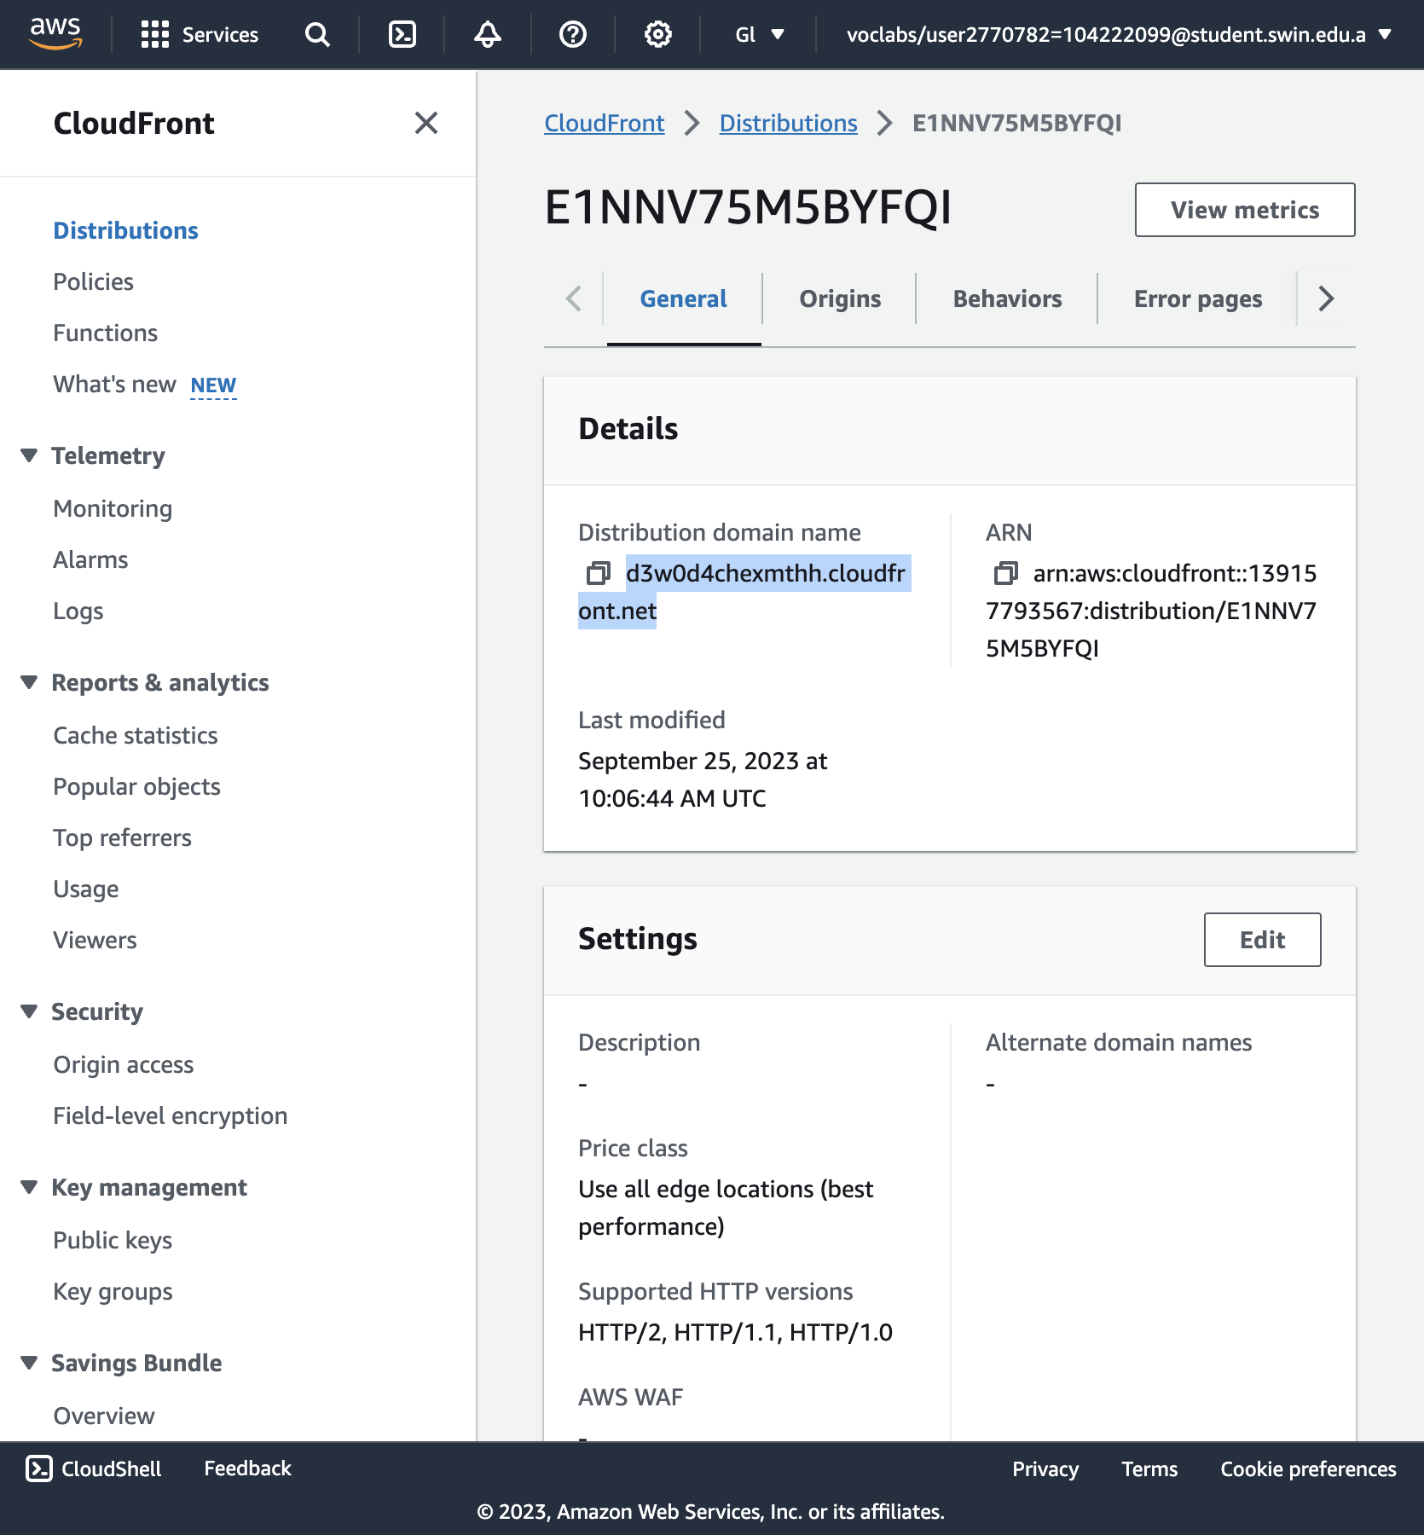

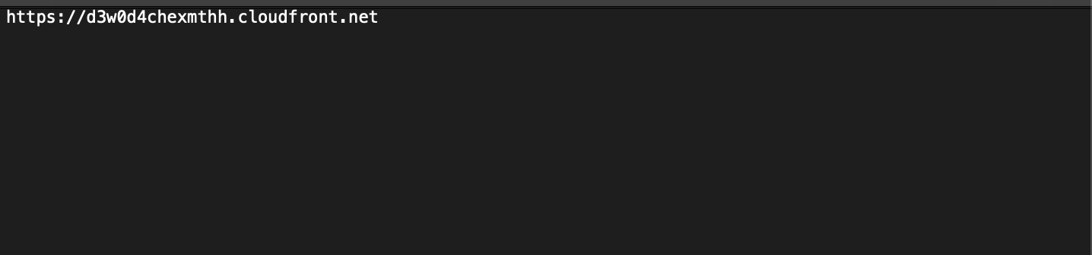

Copy the **Distribution domain name** and paste it into a text editor.

**Obtain the Playlist File Path**

1. On the **Services** menu, choose **S3**.

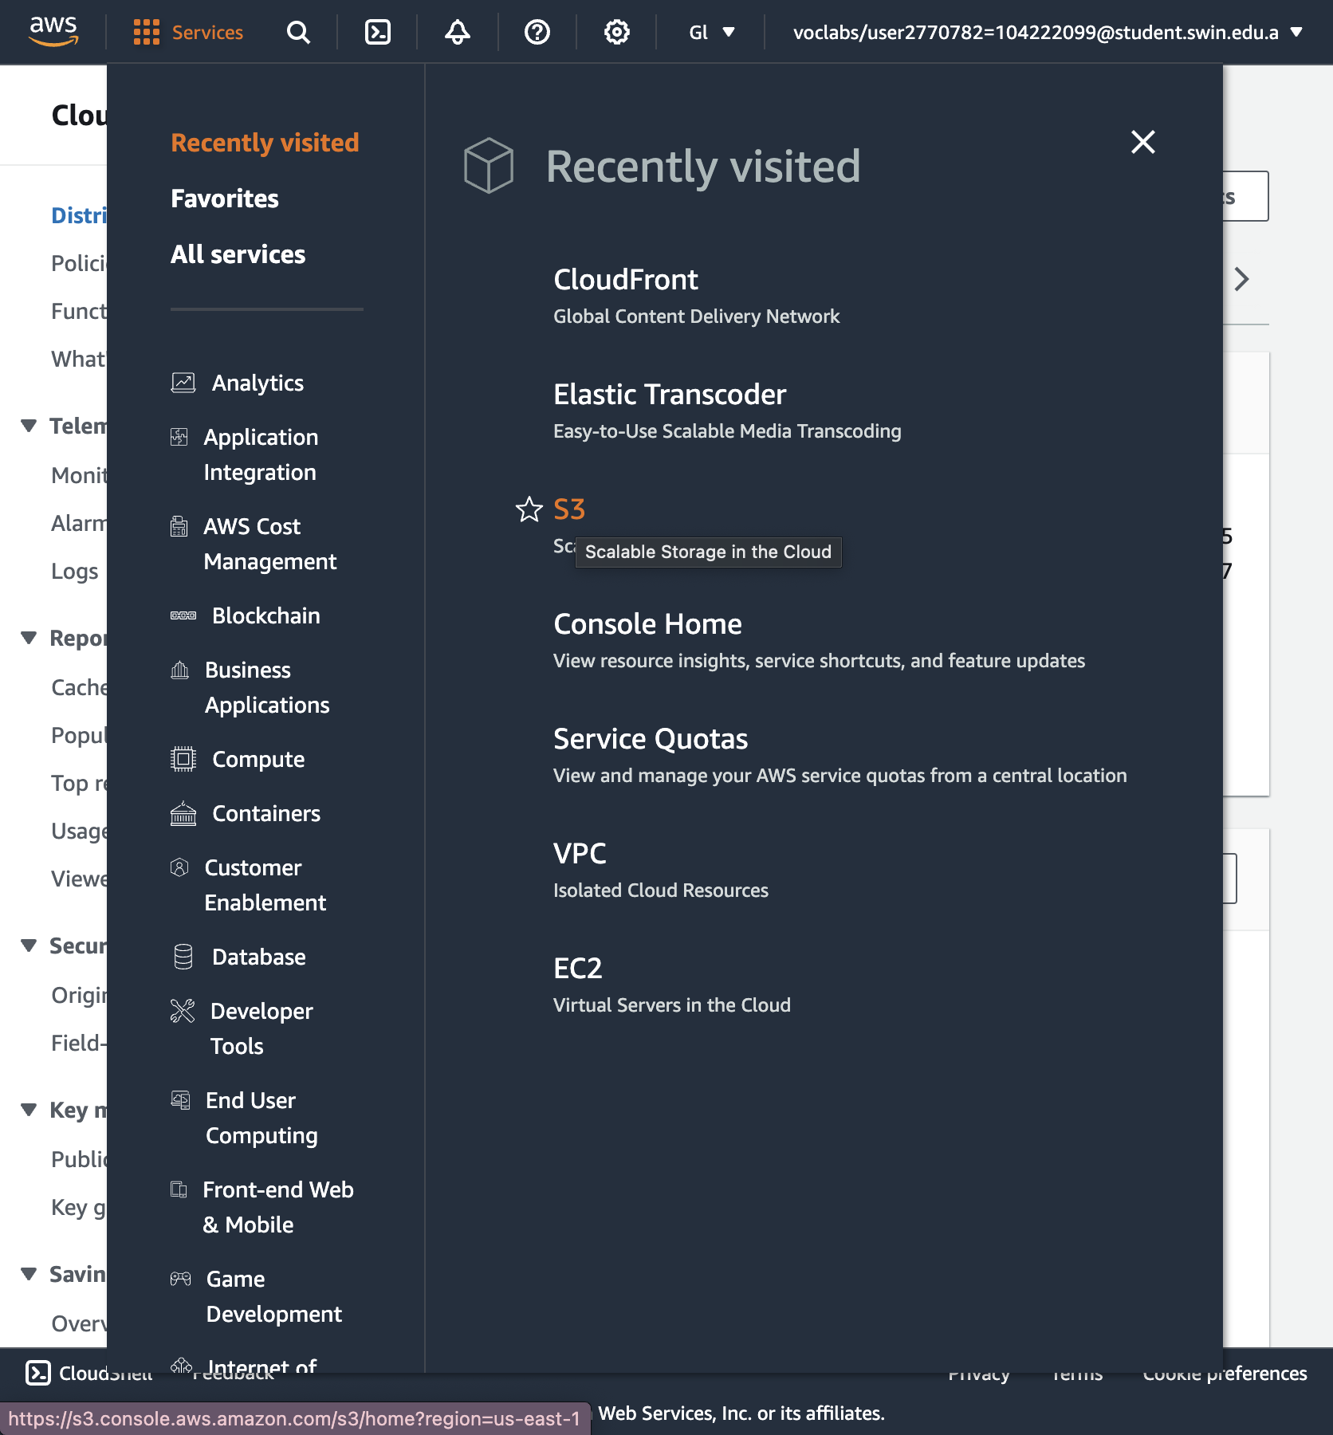

1. Select the **awstrainingreinvent** S3 bucket.

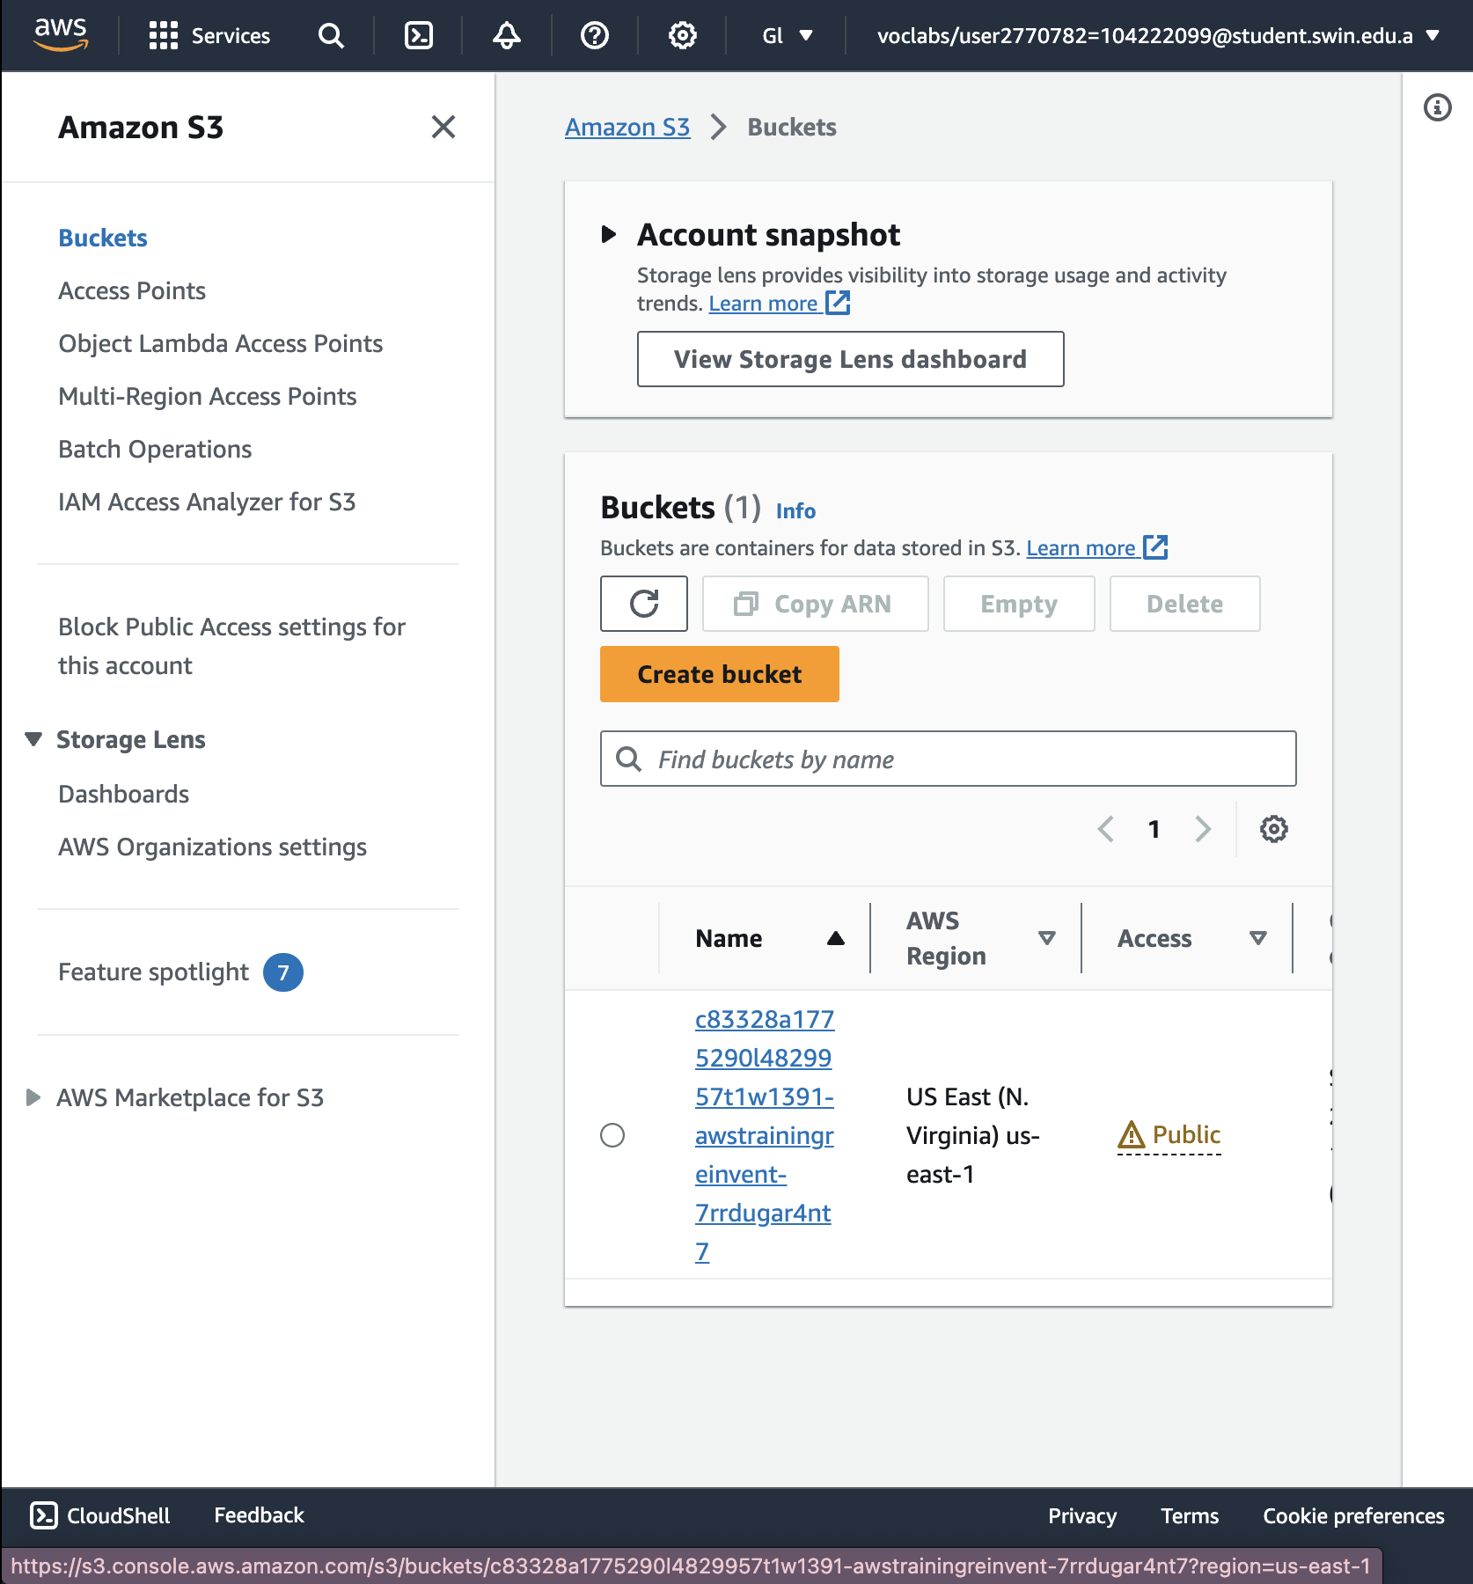

37. Open the **output** folder (which contains the output of the transcoding job) and select the **primary.m3u8** playlist file.

This is the file that you will play on your mobile device.

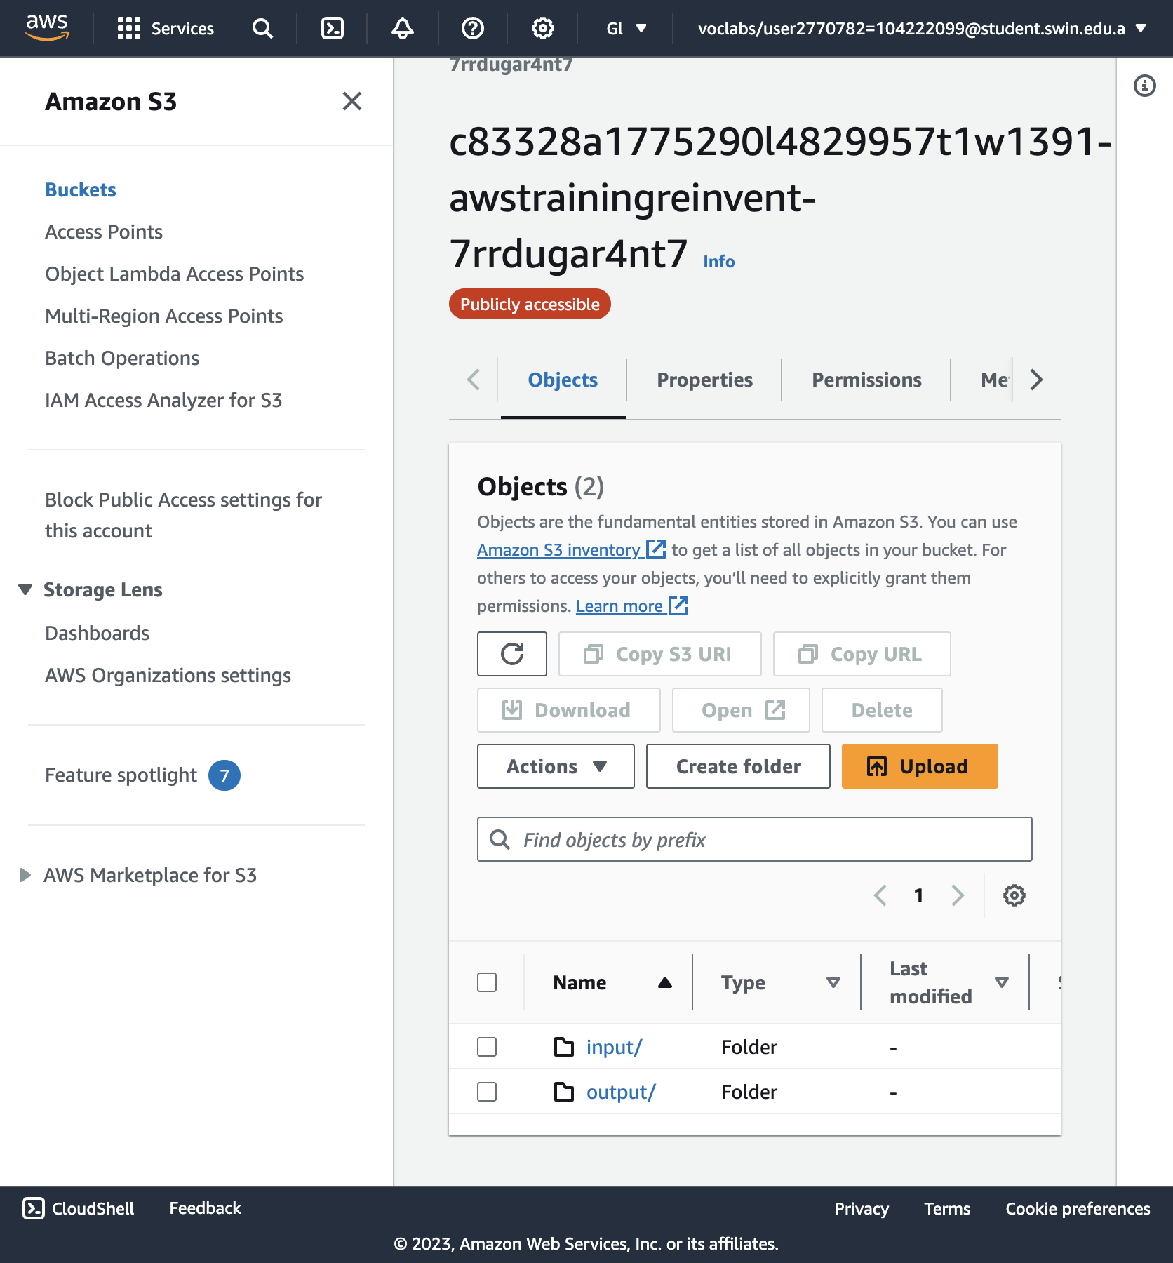

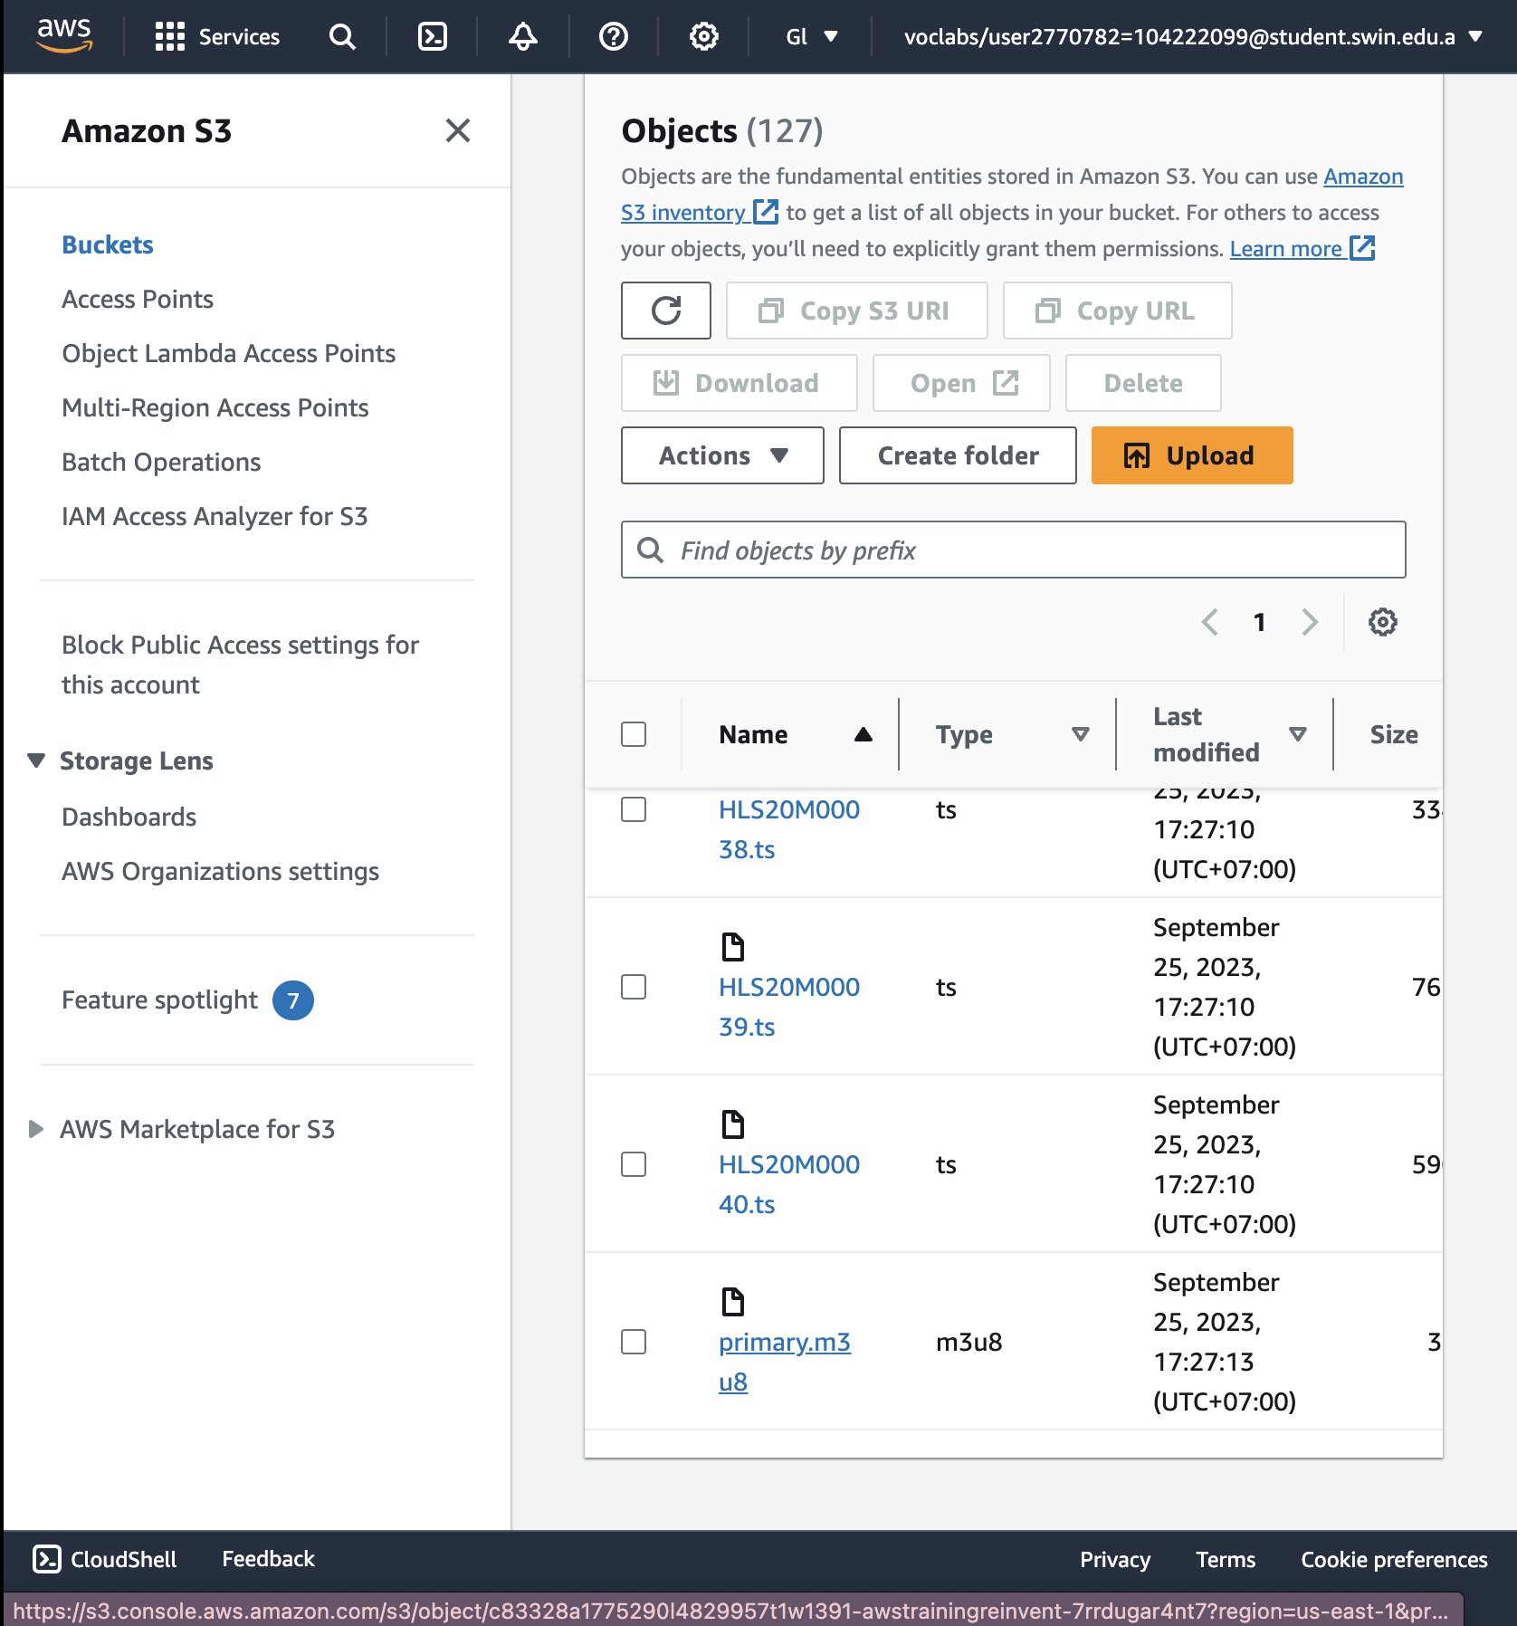

38. In a text editor, construct the URL by appending /output/primary.m3u8 to the end of your CloudFront domain name.

The new URL should look similar to: *d1ckwesahkbyvu.cloudfront.net/output/primary.m3u8*

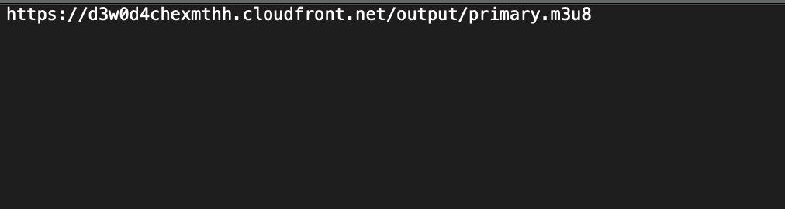

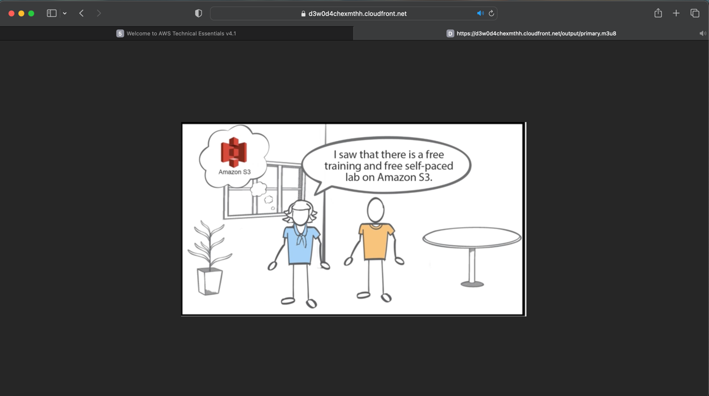

The stream plays successfully on Desktop

The stream plays successfully on Mobile device.

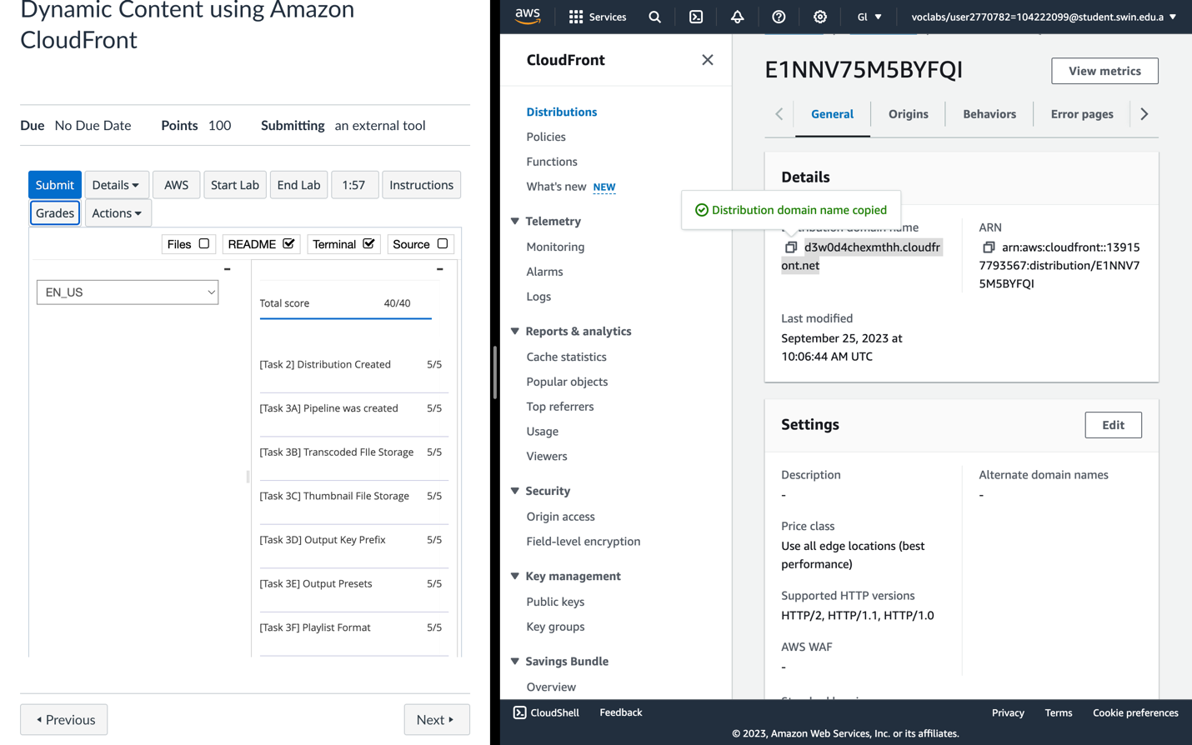

Submitted and Assignment recorded

END LAB.